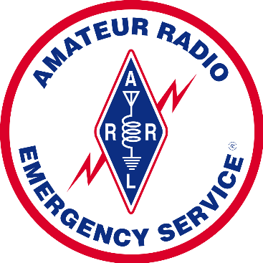
VOLUNTEERS WANTED!
The Western Massachusetts Simulated Emergency Test (SET) will be held Saturday, 04 October 2025 from 10AM to 2PM local time (rain date Sunday 05 October) and WMA ARES is looking for amateur radio operators willing and able to help out!
THE SCENARIO
A large-scale cyber attack has disrupted normal electrical power distribution and internet systems throughout the Western Massachusetts Section. None of the amateur radio repeaters are on the air except for those few with backup generators or solar power.
THE MISSION
WMA ARES has been asked to staff shelter locations and pass logistics traffic using ICS-213 forms between local shelters and MEMA and/or FEMA.
THE PLAN
With few of our wide-area repeaters available, how will we pass the traffic? VHF Simplex using relay stations in elevated locations? HF 80-meter NVIS? WinLink? We haven’t decided yet, but you can help us solve this problem!
Contact the WMA Section Emergency Coordinator, Chuck Chandler WS1L chandlerusm@gmail.com, or your local District Emergency Coordinator or Emergency Coordinator, http://www.arrl.org/field-appointments
