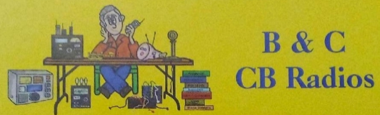
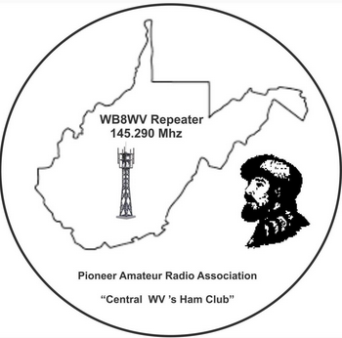
B&C CB RADIOS
&
PIONEER AMATEUR RADIO ASSOCIATION
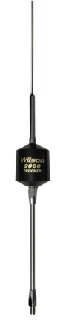
DATE: SATURDAY FEBRUARY 22, 2025

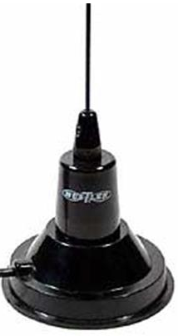
LOCATION: GILMER COUNTY RECREATION CENTER
1365 SYCAMORE RUN ROAD
GLENVILLE, WV 26351

TALK IN: (HAM) -145.290 PL TONE 91.5 (WB8WV)
(CB) CHANNEL 35

COST: $10.00 PER TABLE SETUP / $5.00 ADMISSION
CHILDREN UNDER 12 FREE

CONTACT: LARRY BARTON (WV8LB/RC)
JLARRYBARTON@GMAIL.COM
1-304-482-6166

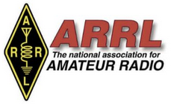
INFO: WE WELCOME ALL TYPES OF HAM AND CB RADIO EQUIPMENT. BUY, SELL, OR SWAP. DOORS OPEN AT 8AM ON SATURDAY FOR SET UP. GENERAL PUBLIC FROM 9AM-2PM. BREAKFAST AND LUNCH WILL BE AVAILABLE FOR PURCHASE AT THE FACILITY. PLEASE RSVP TABLE RESERVATIONS FOR PLANNING PURPOSES. THERE WILL BE TABLES AVAILABLE SATURDAY MORNING.

TESTING: HAM RADIO LICENSE TESTING WILL BE AVAILABLE
FROM 10AM – 12PM. ($20/TEST) + ($35 FCC FEE IF YOU PASS)
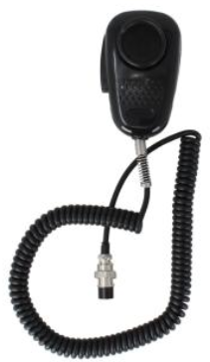
DOOR PRIZES: SEE PICTURES ON FLYER (MULTIPLE)
