 --.- … - --.- … - --.- … -
Q S T Q S T Q S T
CALLING ALL HAMS
2023 PARC ANNUAL CORN ROAST

SUNDAY, SEPTEMBER 17, 1500 HRS
QTH OF PAUL VE3AXT & SANDY XYL
71 SAVIGNY RD., STEWART HALL,
OTONABEE-SOUTH MONAGHAN TWP

BRING POTLUCK DISH, LAWN CHAIR,
BUG SPRAY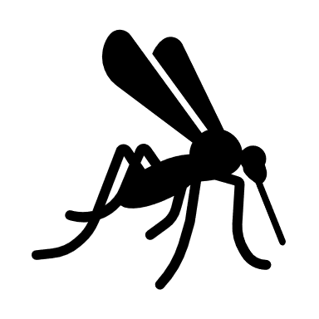 , DRINK (we will have punch & coffee)
THE CLUB WILL PROVIDE CORN, CONDIMENTS, BURGERS
If it rains, we go into the barn with the chickens (they LOVE corn!)
RSVP BY EMAIL TO PAUL
IF YOU NEED DIRECTIONS, CALL, TEXT OR EMAIL
705-749-7151 or ve3axt@rac.ca

