SILENT AUCTION OF K9IA’s RADIO EQUIPMENT
- Icom IC-706 transceiver. 100W. Covers 160M up through 6M and includes coverage of 2M. Has an optional CW filter installed. This vintage radio has been manufacturer discontinued. Manual included. $275
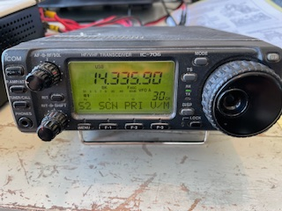
- Icom IC-703 transceiver. 10W QRP. Covers 160M through 10M. Also has general coverage receive capability. Has an optional 500Hz CW filter installed (FL-52A) and the optional UT-106 DSP receiver unit installed. I worked W3US in the FQP with this radio. This vintage radio has been manufacturer discontinued. $275
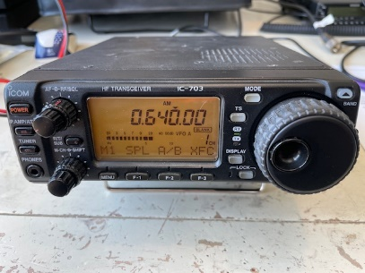
- Icom IC-7000 transceiver. 100W. Covers 160M through 6M plus 2M plus 440MHz. General coverage receive. Digital voice recorder standard. Original HM-151 hand microphone is included. Also mounting brackets, separation cable to place the head in one location and the base in another for mobiling, original box and a copy of the user manual. $700
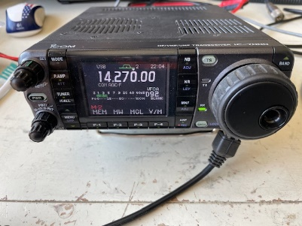
- Timewave DSP-59+. Copy of the manual is included. $35
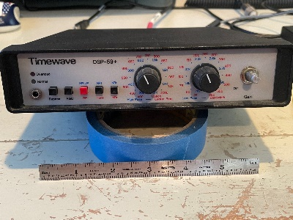

- Ramsey QRP AMP. I could not find anything about this particular model, and Ramsey is out of the kit business. Probably a single-band amp. AS IS. $5
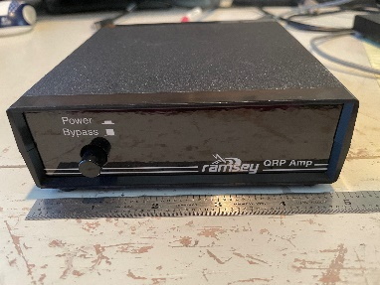
- MFJ 16010 random wire antenna tuner. Manual is included. Not for coax-fed antennas. Use a banana plug to plug a wire into the antenna jack and tune the wire with this device. Up to 100W. $25
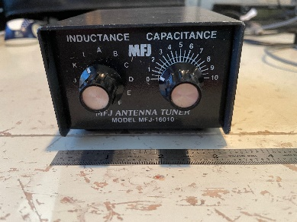
- Kent iambic CW paddle. $50
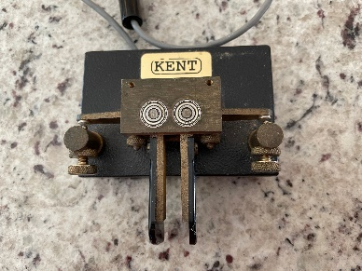
- MFJ 2-position coax antenna switch. Middle position can be grounded. $25
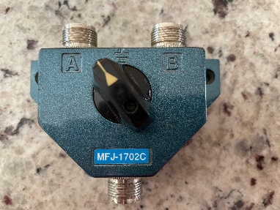
- Begali Spark straight key. $120
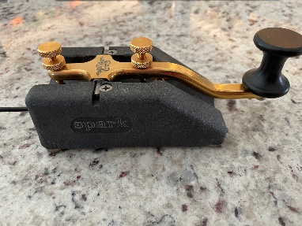

- TenTec 40/20 QRP transceiver. This is a cool little radio, but it has a major problem. No information appears on the display. I plugged in headphones and heard band noise. I tuned around and heard a bunch of CW signals operating one of the weekly CWOps sessions. I couldn’t tell whether it was 20M or 40M because of the display issue. The radio tunes continuously from 5MHz to 19MHz. I printed out the manual. Works on standard 12VDC. AS IS. $20
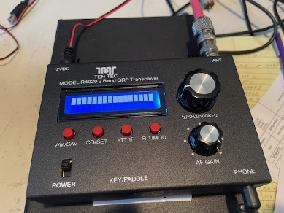
- Single-lever CW paddle from American Morse Equipment. It is the Bushwacker Single Lever model that sells as a kit or built. $50
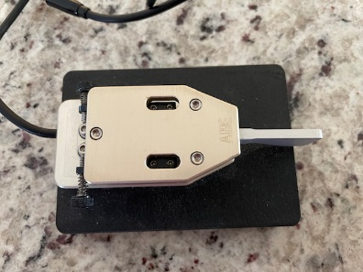
- Icom AT-180 antenna tuner. No interface cable found. Untested. $100
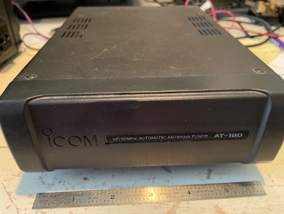
- WinKeyer USB. This is an early version of the famous WinKeyer devices. A WinKeyer goes between your computer logging program and your transmitter to smooth out CW sending. It compensates for times when your computer might prioritize some other task over sending CW. Untested. $5
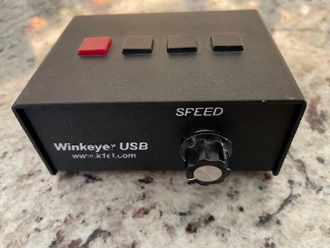

- Powerwerx noise filter. 20Amp max, 16Amp continuous. $5
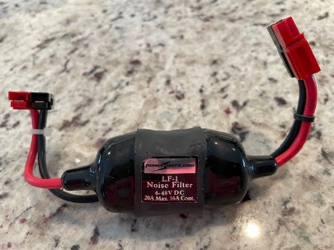
- RF Concepts 2M power amplifier. 2W in, 30W out. Powered by 12VDC. Untested. $30
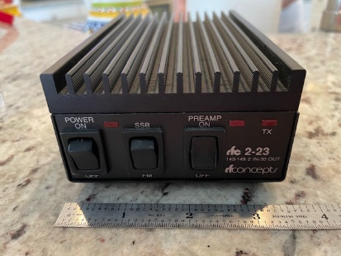
- Bao Feng microphone. $5
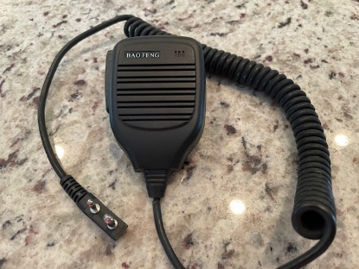
- RIGrunner 4005H 12VDC distribution panel. Outputs can sum to 40Amps. Fused input and output. $25
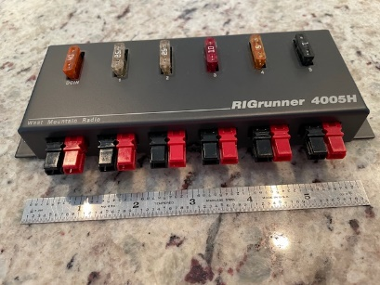
- Elecraft SP3 loudspeaker. Includes cable. Will work with just about any radio. $90
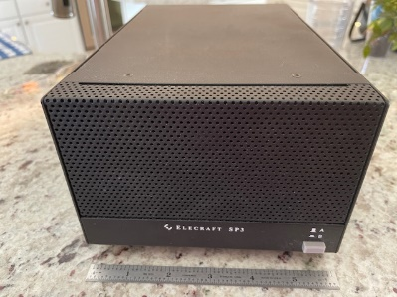

- Powerwerx switching power supply with powerpoles on the front and screw terminals on the back. Model SS-30 DV. $50
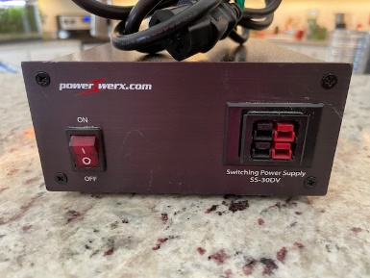
- MFJ dry dummy load. 50 Ohm, 300W max. $40
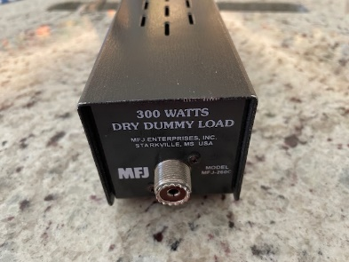
- Elecraft KPA500 solid state power amplifier. Up to 500W output with drive less than 20W. Sold as a package with the Elecraft KAT500 antenna tuner. Manuals included. $2700.
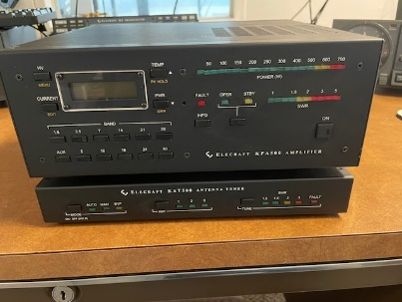
- Slug for a Bird Model 43 wattmeter. 5W, 100-250MHz. $30

- Slug for a Bird Model 43 wattmeter. 5W, 200-500 MHz. $30

