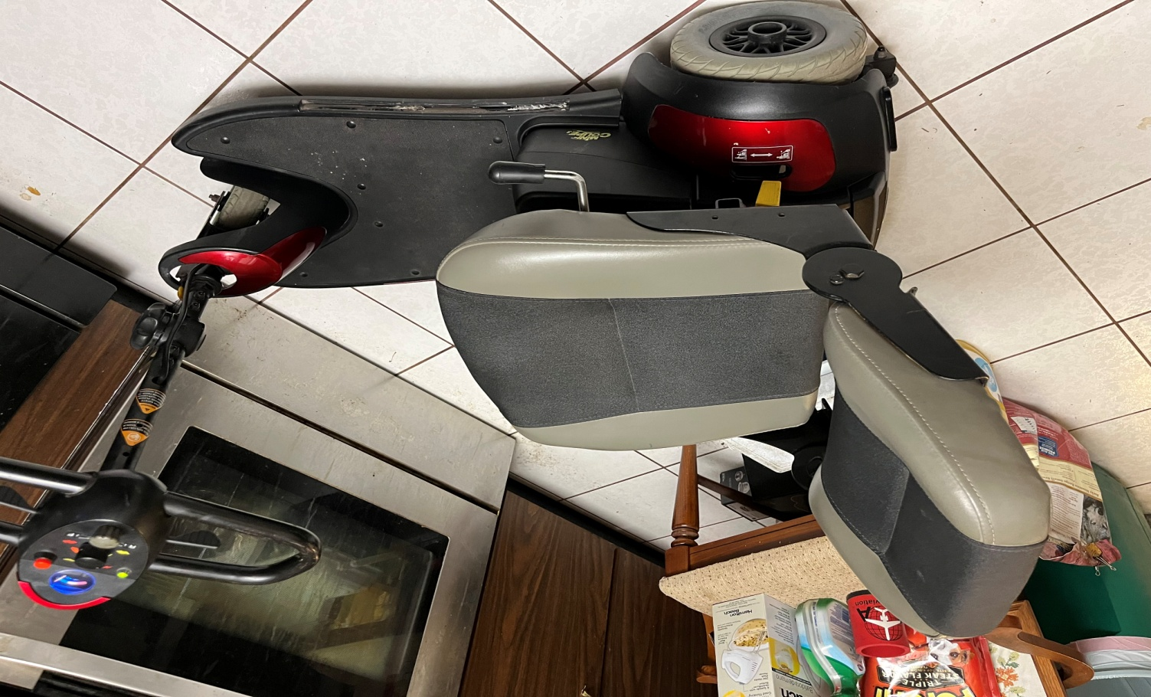

MERITS S-539 SCOOTER
Scooter has brand new 22ah batteries. Has been gone through and cleaned. Scooters on-line have 18ah batteries and sell for 1100-1200. Comes with a basket on front (not seen inpicture).
Runs great and is 300 pound capable. Am asking $850 delivered.

Scooter can be taken apart and put in trunk in three pieces. I will possibly take amateur gear in partial trade depending on items. Please contact Wayne at 813-473-0831 if you have any questions.
Thank you and God Bless.

