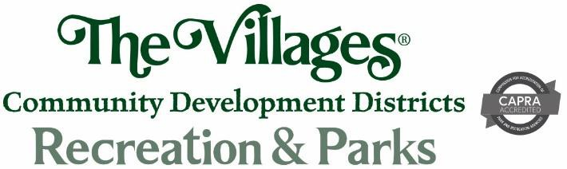

Village Community Development Districts’ Recreation Department VOLUNTEER INFORMATION SHEET
Resident Lifestyle volunteers offer lifestyle services to fellow residents. Your interest to commit your time, talents, skills and energy to other residents enhances the quality of life for your fellow residents.

APPLICANT INFORMATION
(Print Clearly)

DATE_______________________

Last Name First Name MI_________________
Address City State Zip________
Phone Cell Phone Email Address_________________________
CONTACT IN CASE OF EMERGENCY:
Name Primary Phone Relationship to you Alternate Phone______________________________

FACILITY SCHEDULING:
Total Number of hours per week you can volunteer LIST BELOW THE HOURS YOU ARE AVAILABLE (FROM – TO) EACH DAY:

DAYS | MONDAY | TUESDAY | WEDNESDAY | THURSDAY | FRIDAY | SATURDAY | SUNDAY
AM
PM

Note: Background investigations may be made for all volunteers who work routinely with vulnerable populations, especially youth, senior adults, and persons with disabilities.

The department will utilize the website http://offender.fdle.state.fl.us for these background investigations.

Print Name Signature Villages ID # Date

Revised: 12/6/13; 11/10/14; 6/22/16; 4/5/17; 5/15/17; 6/16/17; 7/20/17; 5/10/18 Revised Logo: 5/25/21

1

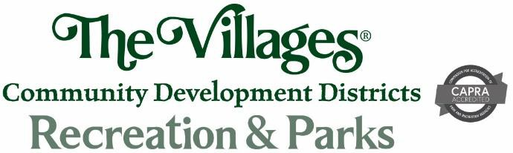

RECREATION CODE OF CONDUCT

When the Recreation Department undertakes programs and activities, we have certain expectations at our recreation facilities and use of the facilities. We require that since you have applied to use the facilities, you agree to do so within the department rules and regulations that govern same. In addition we require that you will address any/all issues as reasonable adults, utilizing the mechanisms that are in place for resolution of such issues.

- The use of obscenity, profanity or vulgarity in any conversations involving participants or department staff will not be tolerated.
- It is everyone's responsibility to maintain a safe, pleasant and comfortable playing atmosphere.
- Every individual who participates in this program has the right to be treated with respect. The Golden Rule "Do unto others as you would have them do unto you" prevails.

OUR CORE VALUES

WE ARE A BIG COMPANY WITH A SMALL COMPANY FEEL AND FAMILY VALUES. WE BELIEVE THE FOLLOWING VALUES ARE CRITICAL TO OUR SUCCESS. WE STRIVE TO PROMOTE THESE VALUES AND DEMONSTRATE OUR COMMITMENT TO THEM WITH OUR WORDS AND ACTIONS DAILY.

- Hospitality
We believe that "the hand shake of the host determines the taste of the roast."

- Hard Work
We exceed expectations with our effort and results.

- Stewardship
We treat The Villages as ours to protect and nourish.

- Creativity
We embrace change for the purpose of finding a better way.

Proprietary Activities at Recreation Centers
The sale of goods and/or services for profit in District facilities requires specific approval from the Director of Recreation. Resident Lifestyle Volunteer Groups are strictly prohibited from receiving remuneration of any kind in return for their involvement in the Resident Lifestyle Club/Activity. Any Resident Lifestyle Volunteer Group that is operating as a propriety operation during their scheduled meeting time will have the room permit rescinded immediately.

Acknowledgement

I have read; fully understand the "Recreation Code of Conduct", "Core Values" and Proprietary Activities as outlined above. I also understand that, if at any time I have questions regarding same that I can contact any member of the Recreation Department for assistance.

Print Name Signature Date

For questions regarding the Volunteer Application and opportunities or the Recreation Code of Conduct please call Recreation Administration Office at 352-674-1800 or visit ow· web site at www.districtgov.org.

2

