The items below are being offered for sale. If interested, please contact Dan Meyer N0PUF directly by text or email. 303-877-8781 or n0puf1@earthlink.net. Please do not reply to this email.
Items below have been tested and are working ok.
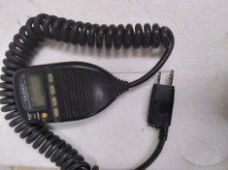 Yaesu MH-29 speaker mic for the FT-530 HT. I have 2. $25 each
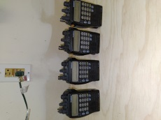 Yaesu FT-530 HT. I have 4. All need batteries and antenna available on ebay. $40 each
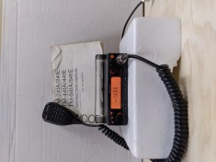 Kenwood TM-241A VHF transceiver with mounting bracket and manual. $100
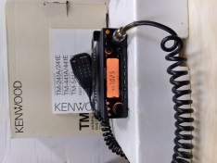 Kenwood TM-441A UHF transceiver with mounting bracket and manual. $100
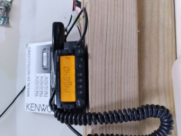 Kenwood TM-G707A Dual bander with bracket and manuals English and Spanish. $150

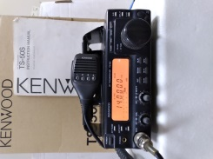 Kenwood TS-50S HF transceiver with mounting bracket and manual. $300
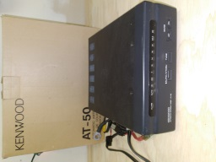Kenwood AT-50 automatic HF tuner. $150
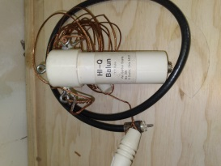 Balun for HF wired for 10 meters. $20

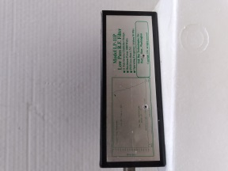 Oak Bay HF low pass filter. $20
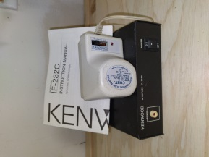 Kenwood IF-232 packet switch with power supply. $50
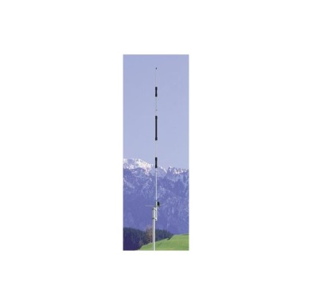Cushcraft AR-270B dual band vertical. $170

Cushcraft AR-10 10 meter vertical. No photo but the antenna is still available new. $75

Cushcraft AR-2 2 meter vertical. No photo but the antenna is still available new. $75

For collectors or those of an older generation….
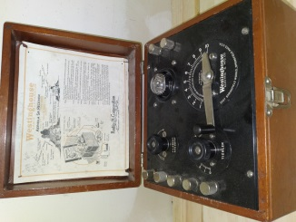 Westinghouse Aeriola (1920’s) HF 1 tube receiver. $200
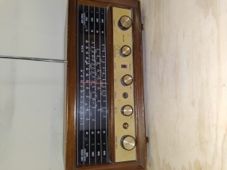 Hallicrafters WR-600 (1950s) 4 band receiver. $75

