ARRL Board Campaign for Greater Secrecy
2025

Here is an ARRL Board of Director’s Policy that has been in effect for 43 years (since July 1982):

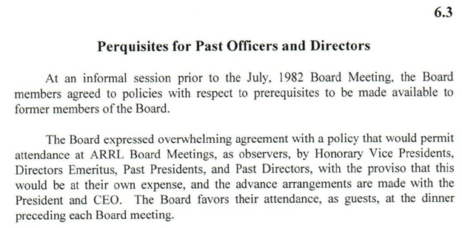

Source: ARRL Director Workbook, https://www.arrl.org/files/file/2024%20Director%20Workbook/6_3%20Perquisites%20for%20Past%20Officers%20and%20Directors.pdf

Now look at the minutes of the latest meeting of the ARRL Board Executive Committee:

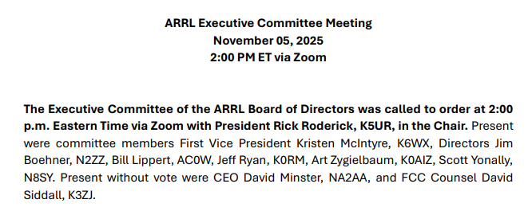

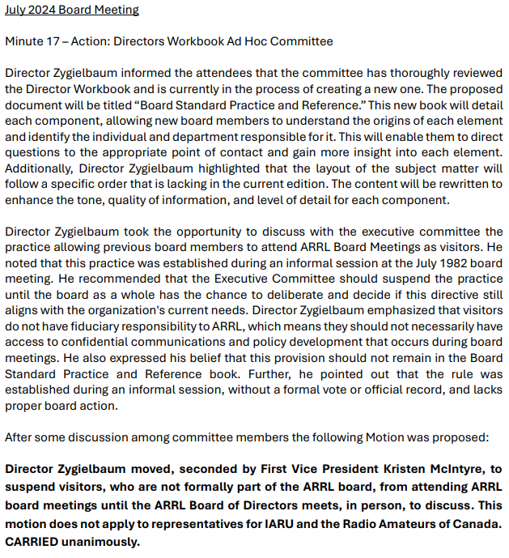
Source: https://www.arrl.org/files/file/About%20ARRL/Board%20Meetings/EC%20Meeting%20Minutes%2011_05_25%20.pdf , at page 5.

Now go look at the Board Meeting minutes for the past two ARRL Board meetings, of July 2025, and January 2025:

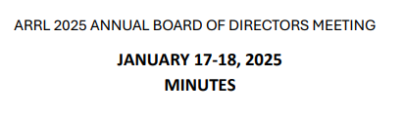
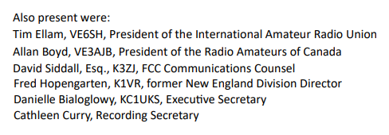
Source: https://www.arrl.org/files/file/About%20ARRL/Board%20Meetings/ARRL%20Annual%20Board%20Meeting%20Minutes%201-17-25%20FINAL.pdf

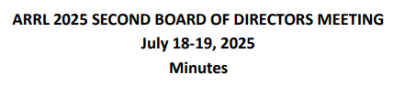
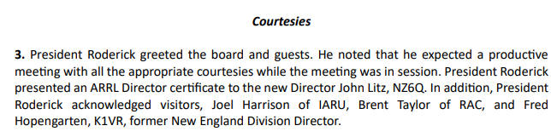

Source: https://www.arrl.org/files/file/About%20ARRL/Board%20Meetings/2025/ARRL%20Board%20Minutes%20Minutes%20July%202025.pdf, at page 3.

Conclusion: The ONLY past director present at the past two Board meetings was Fred Hopengarten, K1VR, past New England Director.
As a result, the ONLY person most likely to be affected by the K0AIZ motion is K1VR.

Note: IARU and RAC representatives have no fiduciary obligation to ARRL, but may attend as a courtesy.

The K0AIZ motion, to overturn a Board policy that has been in existence for 43 years was aimed by K0AIZ solely at K1VR.

Why? Because K1VR opposed, in writing, prior K0AIZ work to hinder anyone but a “good old boy (or equivalent)” from being elected to the Board. See What the heck is the ARRL Board of Directors thinking this time?

Those voting unanimously in favor of the K0AIZ motion to change a 43-year-long courtesy: K0AIZ, K6WX, N2ZZ, AC0W,K0RM, and N8SY.

Note: K1VR is the co-author, with N5AUS, of the ARRL’s bill to aid hams who live in HOA’s that is now before Congress. What have K0AIZ, K6WX, N2ZZ, AC0W,K0RM, and N8SY done to help ham radio? [OK, let’s concede that, in their own eyes, they have each helped ham radio by promoting secrecy and protecting themselves from being voted out of office.]

