**For Immediate Release  
Press Release #8  
Dec 2, 2023**

**TX5S Clipperton Island DXpedition  
(NA-011)**

**January 18 – February 1, 2024**

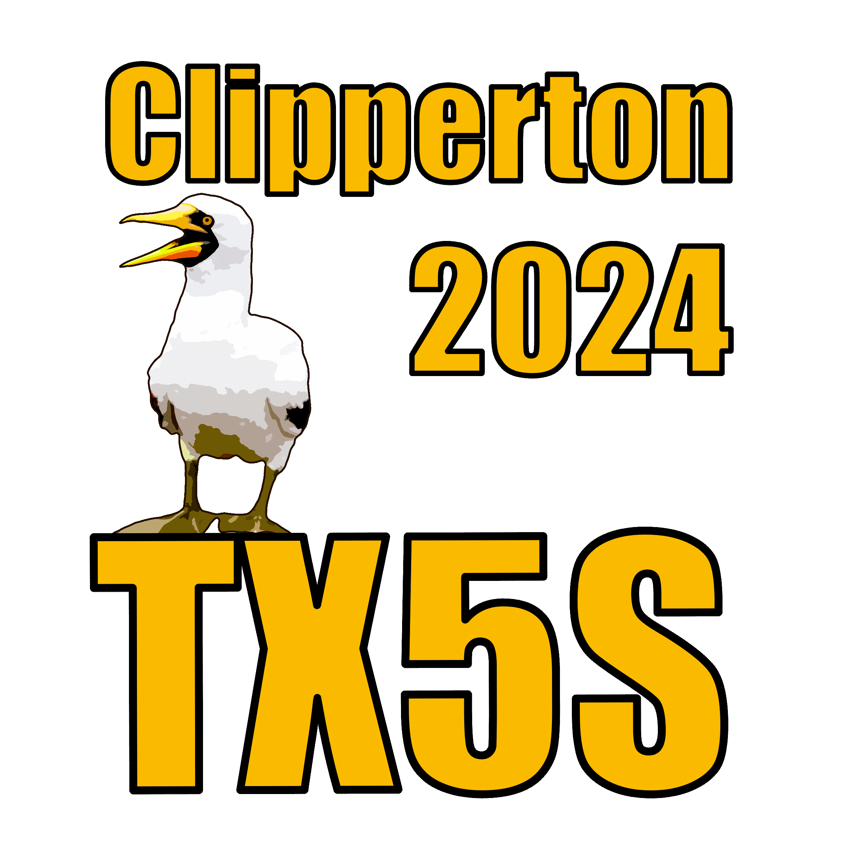

**Equipment Week:**During the first week of December several team members will meet in Northern California to prepare the campsite and radio equipment for shipment to our boat Shogun which is docked at San Diego. We will inventory the tents and review their installation procedures, the Elecraft transceivers will be integrated with the computers, amplifiers, and the island’s WIFI environment will be configured and integrated with Starlink. The EME and satellite stations are separate turnkey packages. Shogun will provide meals on the island; we will provide the necessary campsite logistics and management.

**Clipperton Island ATNO Day Planned**Clipperton remains **#26** most wanted in Europe and **#37** most wanted globally. It will have been 11 years since the last major DXpedition to Clipperton we know there are many people that need it for an All Time New One and band fills.

**Log Uploads**We plan to upload the logs at least once a day to both Clublog and to M0URX.com

Shortly after we leave the island confirmation requests (OQRS) will be processed **only** at M0URX.com

Not in Log and busted calls will be investigated by submitting the form at M0URX.com. Please, no emails about Not in Log or busted calls, you must use the reporting form on the OQRS system.

**FT8 Operation**The team will use **WSJT-X** exclusively for all FT8 operation. We plan to use Fox / Hound on non-standard frequencies. Occasionally, we might start up on a standard frequency in normal mode, then QSY. See the website for the band plan.

**Groups.io Forum**The pilot team will be using Groups.io to collect input from the DX community. The process worked so well at VP8PJ we will again use it again. A Groups.io account is required to post to the group. You may subscribe to the forum by sending an e-mail to: [Clipperton-2024+subscribe@groups.io](mailto:Clipperton-2024+subscribe@groups.io)

**Fundraising:**The long-standing DX-pedition funding model is to split the DX-pedition cost equally between the expedition team and the DX community, i.e., organizations and individuals. TX5S donations are only at ~45% of the goal. While adding a donation to your OQRS request is always appreciated, the cash flow challenge is real, we must pay the bills before we sail, we need your help.

Since the last press release the following organizations have joined the project as sponsors:

* Northern California DX Club
* Fort Wayne DX Association

Sponsor logos appear on our website and will appear on the TX5S QSL card.  
  
We wish to thank the organizations and individuals who have already pledged their support to TX5S and ask those of you who have not yet processed a donation to consider supporting the project before we sail on January 11, 2024. After the books close, all sponsoring clubs / foundations will receive a TX5S financial summary.

**Social Media:**Facebook: [https://www.facebook.com/tx5s2024](https://www.facebook.com/tx5s2024?__cft__%5b0%5d=AZUmLWbBHUhzYv8gMYi6g_j3kvguPWMuTNAfsmJis2cSCcSd3GDAEkRXBGQTTD71M2xDDSRcq0eqCymAOLEevO95AWeYfNozEnNu6VruV-lqI43bF9DB_WHOtilryaEI-SRusUUOLW2Op4vQ7cWydh1cmvkBzRpn-r9xQQoVm3aEmyoHslad1q99H5ZEPM7D19Bx8uLY5Vp9c8hDH4DFWK69&__tn__=-%5dK-R)

Website: [TX5S.net](https://clip.pdxg.net)

Groups.IO: Clipperton-2024   
  
Questions to: [info@pdxg.net](mailto:info@pdxg.net)  
  
73,  
Clipperton 2024 Team