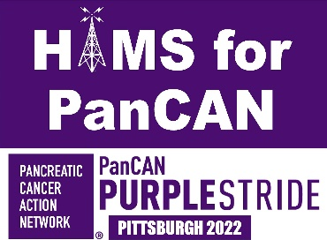
2777 Leechburg Road
Lower Burrell, PA 15068
October 19, 2022

Hello fellow amateur radio operators,
My name is Richard Ryba/WQ3Q. I am writing to you today to ask for help in setting up a nationwide Special Event to coincide with the Pancreatic Cancer Network’s Purple Stride day. It raises awareness regarding their support for affected patients like me, as well as, helping to fund research to find a cure.
This past April our local team, (Hams for PanCAN,) ran the special event N3P at Skyview Radio Society. Perhaps you saw the article in the September QST magazine about our efforts then. The Purple Stride events occur in 60 city locations across the US that day. This coming April 29, 2023, I would like to set up a network with radio clubs in the 10 sections throughout the nation, to work the event in their area. You can find out which cities are hosting Purple Stride events and more event information at PanCAN PurpleStride - Taking Steps to End Pancreatic Cancer .
I also would like stations to run a special event bonus station at the Purple Stride event like I did in my hometown.
QSL cards will be available for contacts and a special clean sweep certificate will be awarded to anyone who contacts all 10 sections. This special event will not request donations on the air, but we will direct anyone who wants to help, to go to PanCAN’s website. No monies are to come to us. Mostly the idea is to raise awareness of PanCAN’s efforts to address the disease and to listen to or share stories of those who have been affected by pancreatic cancer. Many of our contacts this year wanted to share their personal stories, others wanted more info for help, and others wanted to do what they could to support the cause. It was surprising how many people have been affected by this cancer in particular.
Please email me in return to be involved, or to be dropped from consideration. If interested in more information about setting up a section special event, contact me directly at rybar1949@gmail.com . Attached is a copy of our QSL card from this past April. They can be personalize them specific to your area, and even highlight one of your local ham’s pancreatic cancer story instead of mine.
I appreciate your time and consideration of my request.
73!
-Rich Ryba/WQ3Q
“Hams for PanCAN” Special Event Coordinator

