**Calvert Amateur Radio Association**

**9 Jan 2025 Meeting Minutes**

**Board of Directors Meeting**

The Board Meeting was called to order at 6:40pm by Vice President, Erik Johnson, KC3QQD as the President was still with our special guest at dinner. More on that later. Present were: Treasurer, Andy Charland, KC3WRX, Secretary Shawn Donley N3AE, and Director Dave Weaver W3PQS. Also attending were members Lisa Kress, Bill N3XMZ and Don, KR3A.

**Vice President** –

* The POTA committee met via Zoom and decided on planning for POTA events once each month except for June (Fiield Day) and December. Andy, WA4BRX, provided the group with a list of POTA locations within the county. In addition to State Parks, there are several National Historical Trails in the county that run through or very close to some county parks.
* Upcoming CARA events include:
  + STEM Fair at Calvert High School on Feb 22nd
  + NVIS Day; the data likely Apr 26. Location TBD
  + Field Day, June 28-29, location TBD
  + Maryland QSO Party, Aug 9th

**Treasurer** –

* Mobile Communications America (MCA) grant of $11,000 deposited to the CARA checking account on December 30th 2024. The grant money will be moved to an interest bearing account in the near future.
* CARA Checking Account as of December 31st 2024:  
  Deposits: $11,332.86.  
  Withdraws: $1,888.75.  
  Balance: $15,191.75.
* CARA Certified Deposit as of December 31st 2024:  
  Balance: $3,106.05.  
  CD will be renewed in March of 2025.

**Secretary**-

* Nothing to report

**Director** –

* Nothing to report

**RACES –**

* Nothing to report

**AUXCOMM –**

* Our meeting on Jan 16 (at the PSB EOC) will be a hands-on digital modes training session. Bring your digital gear and an antenna or dummy load.

**Skywarn –**

* Nothing to report

With no further business, the meeting adjourned at 7:11pm

**General Membership Meeting**

Meeting was called to order at 7:31pm with the Pledge of Allegiance.

Present were:

|  |  |  |  |
| --- | --- | --- | --- |
| Brian KB3WFV | Erik KC3QQD | Tom KC3YZZ | Dave W3PQS |
| Bill N3XMZ | Shawn N3AE | Don KR3A | Dale N3ILH |
| Nigel G0JKN | Peter N3PH | Daire AC3KX | Joe KC3RBJ |
| Mark KC3VNH | Andy KC3WRX | Richard W3RBR | Miriam KC3ASQ |
| Cammi KA3RUR | Lisa Kress | Roger Cassell VP MCA | Kara Buckmaster Calvert EM |
| Crystal Dowd, Calvert Public Safety | Ricky Cox Calvert Sheriff | Tod W3EME (Zoom) |  |

* Minutes for November 2024 were approved.

**President**

* So far 15 members have paid dues for 2025. Please use our web site to renew. It’s easy.

**Vice President** –

* Erik provided an overview of Parks on the Air (POTA) and plans for CARA’s once a month POTA activations starting soon.

**Treasurer –**

* See the Treasurer’s report in the Board minutes above.

**Secretary –** No new inputs.

**Director** - No new inputs

**RACES** – No new inputs

**ARES/ Skywarn** – See the Board minutes above.

**Misc –**

The meeting’s very special event was the presentation of a $11,000.00 grant check by Mr. Roger Cassell, Vice President of Mobile Communications America (MCA). CARA submitted a proposal in response to MCA’s “MCA Day.” Program.

Our proposal was one of eleven winners across the country. See <https://callmc.com/mca-day-grants-2024/> for the winners. The grant money will be used for public outreach and STEM education consistent with the proposal’s objectives (shown at the end of these minutes). Besides Mr. Cassell, we had Calvert County Sheriff Ricky Cox, Deputy Public Safety Director Crystal Dowd, and Calvert Emergency Management Specialist Kara Buckmaster in attendance for the MCA check presentation.

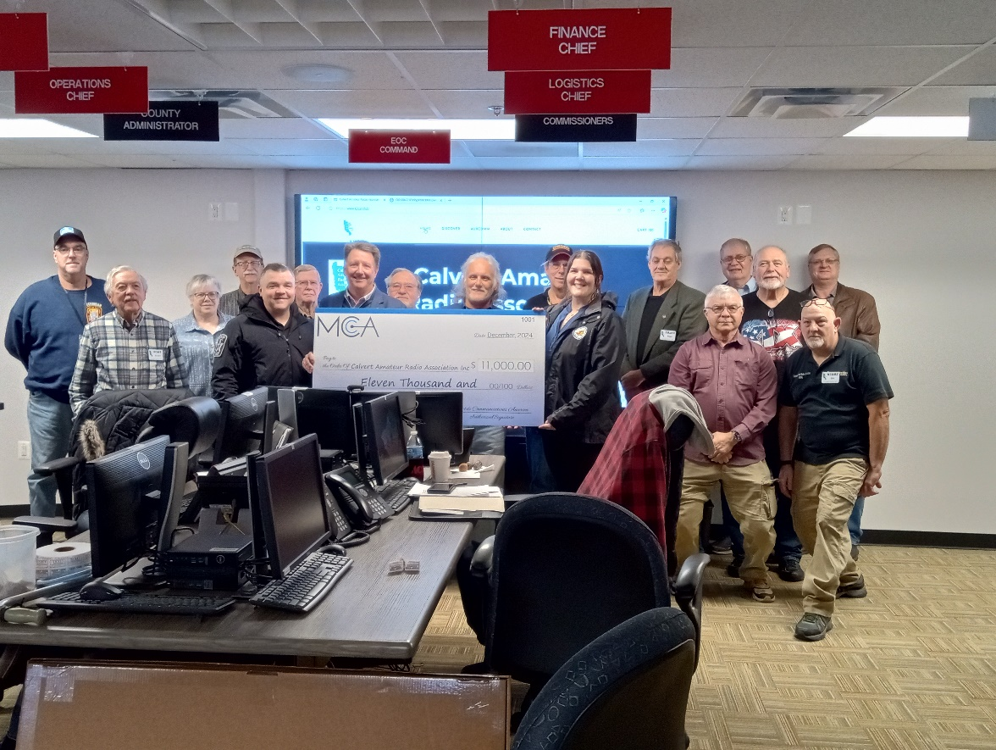

After presenting the check, Mr. Cassell provided a description of the FirstNet 700MHz. FirstNet is the only nationwide wireless broadband communications platform built with and for America’s first responders and the public safety community. MCA is responsible for the FirstNet installation and support in Maryland and numerous other parts of the country.

Mr. Cassell took a tour of the Calvert 911 dispatch center as well as the amateur radio installation at the EOC.

Various CARA members also shared information on other aspects of amateur radio, including Skywarn, Echolink, APRS and the technical support we provided to Calvert Department of Natural Resources in setting up their MOTUS wildlife tracking system ( <https://motus.org/> ).

Kara Buckmaster expressed her thanks for CARA’s long time support of Calvert Emergency Management. She also brought to our attention a new weather monitoring system going into the county in three locations. See <https://mesonet.umd.edu/>

The 50-50 pot was $62.00. Miriam, KC3ASQ, was the lucky winner of $31.00

The meeting was adjourned at 8:30pm

CARA’s MCS DAY Proposal Objectives

Our proposed program, CONTACT, is a multi-faceted, long term program designed to spark an individual’s interest in to the world of RF communications and the opportunities it provides. Some of the elements of the program include:

• Outreach through marketing on digital platforms and live event demonstrations.

• Education, through seminars and classes.

• Training, through active participation in on-air events and local government emergency communication drills.

• Testing, through Federal Communication Commission (FCC) license exams.

CONTACT will encourage youth to explore the world of Science, Technology, Engineering and Math (STEM) found within the RF communication industry. By supporting individuals or other organizations with the necessary knowledge, facilities, and equipment to further their learning.

CONTACT flexibility allows for multiple approaches to achieving its goal. The initial approach will be to promote activities and information on the CARA website and through CARA’s Facebook and YouTube social media platforms as well as contact with local schools.

The messaging would be primarily designed to encourage attendance and participation in CARA sponsored or supported events. These events provide an opportunity to distribute pre-printed material that presents the reader with information on RF communications. Interested individuals will be extended invitations to attend CARA seminars and classes to further their understanding of the many facets of RF, ultimately testing for and receiving their own FCC license. Their exploration continues with hands-on application of their knowledge by building, installing and operating local and wide area radio communication systems, and designing, programming and implementing RF communication control systems.

In order to maintain a high interest level, CARA proposes to use part of the grant money to purchase and maintain basic electronic test equipment to use during seminars and classes rather than rely on just lectures and presentations.

CONTACT will also augment our current support of backup emergency communications with the local governments. CARA participants design, install, maintain and operate VHF and UHF radio repeater systems as well as VHF, UHF and HF simplex radio systems, both analog and digital, providing backup communications for several Southern Maryland counties and to Maryland Emergency Management.