**Calvert Amateur Radio Association**

**08 Aug 2024 Meeting Minutes**

**Board of Directors Meeting**

The Board Meeting was called to order at 6:40pm by President Brian Kress. Present were: Brian Kress KB3WFV, Vice President Erik Johnson KC3QQD, Secretary Shawn Donley N3AE, Treasurer Richard Ratcliffe W3RBR, Director Dave Weaver W3PQS, and members Andy Charland KC3WRX, Bill Hackett N3XMZ, and Lisa Kress.

**President**- Commented on the National Night Out activity, see the notes below for the Members Meeting.

**Vice President** – See notes below for the Members Meeting.

**Treasurer** – The treasurer reported we have $5186.90 in our bank account as of July 31 plus a CD that was issued in the amount of $3000.00 and now valued at $3059.34.

**Secretary**- Had nothing new to report.

With no further business, the meeting adjourned at 7:10pm

**General Membership Meeting**

Meeting was called to order at 7:34pm.

Present were:

|  |  |  |  |
| --- | --- | --- | --- |
| Brian KB3WFV | Erik KC3QQD | Shawn N3AE | Dave W3PQS |
| Bill N3XMZ | Nigel G0JKN | Dick W3RBR | Andy WA4BRX |
| Mark KC3VNH | Andy KC3WRX | Dave KC3RWT | Daire AC3KX |
| Lisa Kress | Adrienne KG5CIL | Phil NO3N |  |
|  |  |  |  |

**President** – CARA’s table at the National Night Out at Brooms Island was visited by members of the public along with the Calvert Sheriff, Ricky Cox, and a representative from the Coast Guard Auxiliary. Sheriff Cox suggested a follow-up presentation on amateur radio for his staff. The Coast Guard Auxiliary representative asked for some assistance with restoring simplex communications capabilities between Coast Guard Auxiliary sites. KB3WFV will follow up on this later. The club distributed handouts including the newly printed CARA “postcards.” KC2QQD ran the “Talk-Around Tuesday” night from the venue using the RACES crossband radio at the Barstow tower. For the event, the crossband antenna was switched from the normal 125 ft high antenna to the antenna at 250 ft on the south side of the tower. Twenty six stations checked in to the net. A map of check-ins is shown below. KC3WRX had his HF portable station set up and made a few contacts including some DX (France). Also helping out were W3PQS, KE6YCO, AE3DT, G0JKN & W3SMM.

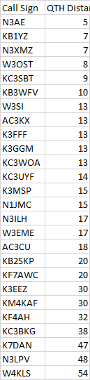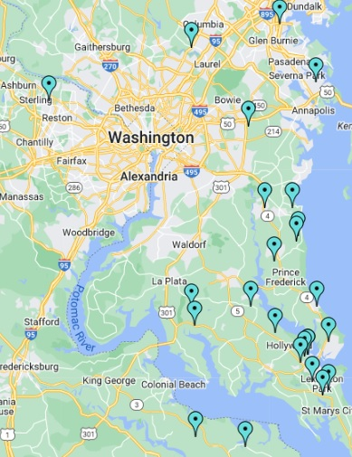

**Maryland QSO Party** – Aug 10 from 10am to midnight. Modes this year are limited to CW and SSB. KB3WFV has purchased 40M and 20M bandpass filters and is building a crossed dipole, one leg for 80M and 40M, the perpendicular leg for 20M, 15M and 10M. The plan is to use these filters and new antenna with two stations and see how that works out. N3AE will set up two networked laptops for logging using the N3FJP software.

**Minutes** - The July minutes were approved.

**Secretary** - Nothing new to report.

**Vice President** - Erik’s report is included above with the National Night Out activity,

**Director**- Still working towards installing a GMRS repeater on the State Highway tower in Prince Frederick by the fall of 2024.

**Treasurer** – The treasurer reported we have $5186.90 in our bank account as of July 31 plus a CD that was issued in the amount of $3000.00 and now valued at $3059.34

**RACES Officer**- The CALVEX dry run was held on August 6th and went well. The EOC was fully staffed but the Maryland Emergency Management was lightly staffed (2 people) in part due to on-going relocation of their office to Hanover MD. It was necessary to wear headphones. The RO is trying to contact RO’s in the adjacent county to work on future coordination of efforts. The “for score” exercise will occur on Sep 10th.

**ARES EC.**- Our next scheduled meeting is on Aug 15. KC3WRX will be providing a refresher on the Incident Command System. The antenna for the crossband radio at Barstow will be switch back to the 125 ft antenna on the north side. Also, the crossband radio will be reprogrammed to expect a PL of 100Hz on all programmed 2M simplex channels. This is necessary to prevent RF noise at the shared tower site from opening the RF squelch and forcing the crossband into transmit until it times out.

**Skywarn** – There’s a tornado watch out for the area this evening. The tornado’s likely source is the left-overs from the tropical storm and are typically less intense and short-lived.

**50/50**- There was no 50/50 drawing at the meeting.

The meeting adjourned at 8:53pm