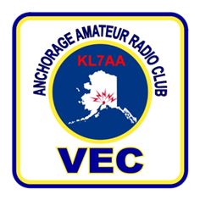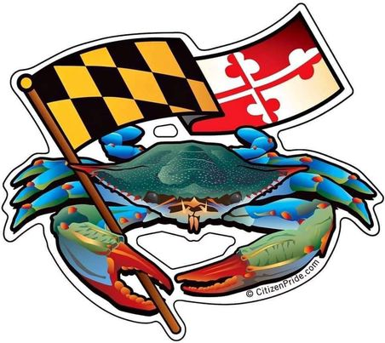

**SoMDVEG**

Southern Maryland (SoMD) Volunteer Exam Group (SoMDVEG)

WHEN: The next SoMDVEG In-Person testing is scheduled for **Sunday, 21 April 2024, 1300-1415ET**. Test will be rendered at the Hollywood Volunteer Fire Department, Training Room, 24801 Three Notch Rd Hollywood, MD 20636, (38.347645, 076.577179)

PRE-REGISTER AT: https://hamstudy.org/sessions/anchorage/inperson

Registration is a three step process; all steps must be completed. The registration cost is $10, payable when you register at the Hamstudy.org site

AVAILABILIITY: New licenses for Technician, or upgrading tests to General and Extra classes can be taken

BRING YOUR OWN: Testing stations are scarse to non-existent. Bring your own Internet (WIFI) capable network device, such as a laptop, tablet, iPAD, even your current cell phone, that is equipped with a current web browser

YOUTH: Under 18 years old are welcome BUT must be accompanied by a parent or guardian who need to “vouch” for the applicant(s)

IDENTIFICATION: A U.S.issued identification, such as a U.S. State Driver License, U.S. Passport, International Passport in the English Language, U.S. Military ID, U.S. DoD Civilian ID, U.S. Visa, U.S. Green Card, U.S. TWIC are required

QUESTIONS: Contact W1JD@comcast.net