D. Tower, Private/Not-for-Profit (Non-Commercial/Governmental) less than 75 feet in height provided that:

1. The distance between the base of the tower and the nearest property line shall equal no less than 75 percent of the height of the tower; and
2. Only one tower is permitted per lot or parcel unless a special exception is obtained from the Board of Appeals; and
3. The base of the tower shall be adequately screened from adjoining properties and the road so as to decrease the visual impact.

E. Tower, Private/Not-for-Profit (Non-Commercial/Governmental), greater than 75 feet in height provided that:

1. The distance between the base of the tower and the nearest property line shall equal no less than 75 percent of the height of the tower; and
2. Only one tower is permitted per lot or parcel unless a special exception is obtained from the Board of Appeals; and
3. The base of the tower shall be adequately screened from adjoining properties and the road so as to decrease the visual impact; and
4. The applicant demonstrates that the proposed tower will not degrade or cause interference to the County's wireless communication systems which include, but are not limited to public safety, administrative and school wireless systems.

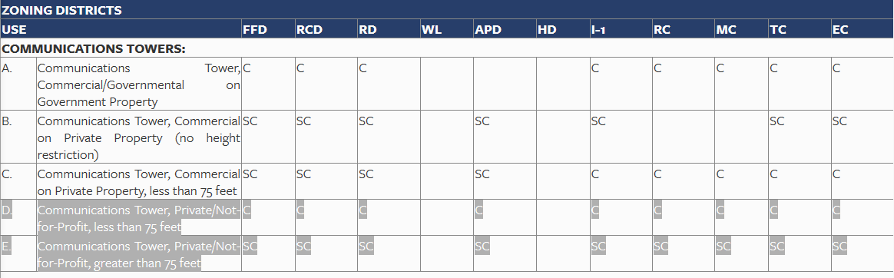

| **KEY TO LAND USE TABLES** | |
| --- | --- |
| P | A "P" indicates permitted uses. |
| S | An "S" indicates in which districts the property owner needs a special exception from the Board of Appeals. Refer to Article 11 of this Ordinance, concerning special exceptions. |
|  | A blank indicates the use is not permitted in the district. |
| C | A "C" indicates the use is permitted only if it meets the conditions specified in the Table of Land Uses. |
| SC | An "SC" indicates the use is subject to a special exceptions from the Board of Appeals and must meet the conditions specified in the Table of Land Uses. Refer to Article 11 of this Ordinance, concerning special exceptions. |
| The letters at the top of the table stand for the names of the Zoning Districts which are as follow: | |
| FFD | Farm and Forest District (agricultural and low-density residential uses). See Section 2-8.01 for a detailed description of the FFD. |
| RCD | Rural Community District (agricultural and low density residential uses). See Section 2-8.02 for a detailed description of the RCD. |
| RD | Residential District (single-family detached, attached, and related uses). See Section 2-8.03 for a detailed description of the RD District. |
| WL | Wetlands District (tidal and non-tidal wetlands). See Section 2-8.04 for a detailed description of the WL District. |
| APD | Agricultural Preservation Districts (Overlay Districts intended to preserve prime agricultural and forestry land). See Section 2-10.01 for a detailed description of Agricultural Preservation Districts. Note: The uses listed in this Section apply to APDs in the County Agricultural Preservation Program only. If a property is in a State APD, the uses must be permitted by the Maryland Agricultural Land Preservation Foundation. |
| HD | Historic Districts (Overlay Districts intended to safeguard the heritage of the County). See Section 2-10.04 for a detailed description of Historic Districts. |
| I-1 | Light Industrial District (Light industrial and warehousing). See Sections 2-8.05 for a detailed description of the I-1 District. |
| RC | Rural Commercial District (commercial properties outside the Town Centers). See Section 2-8.06 for a detailed description of the Rural Commercial District. |
| MC | Marine Commercial District (primarily for businesses which supply and cater to marine activities). See Section 2-8.07 for a detailed description of the Marine Commercial District. |
| EC | Employment Center District (mixed-use office parks, flex space, light manufacturing, warehousing, colleges, universities, and research and development businesses). See Section 2-8.09 for a detailed description of the EC District. |