USING A BUG-e WITH TWO LEVERS, THE BUG WITH "COOTIE DASHER"

If semi-automatic BUG and even automatic, are studied in all

their constructive options, from 1904 to the present day, then BUG with two levers, which

alternately pressing the index finger to the left, then to the right, producing a nearly uniform

sequence of dashes,

Is in the world is practically unknown.

The fact is that such a BUG was made in the beginning of the Great Patriotic War (World War

2) in the USSR solely for use on communication lines of the special services.

Advantages of semi-automatic with two levers are obvious - it is exhibits a noticeable

improvement of the timing of the dash.

At medium operating speeds of 130-160 characters per minute transmission (26 to 32 wpm)

on the BUG-e with two levers is indistinguishable by ear from the transmission using the

electronic

key, which indicates a high quality of transmission in the absence of "Handwriting", i.e. some

peculiarities in the sending, peculiar to a certain operator. This "Handwriting" is called an

operator's "fist" in English.

.

Working position of the hand

The overall working position of the hand and fingers when working on BUG-e with two levers is a

little different from the position for working with a bug with one lever.

The hands and the movements of the wrist are the same, but the series of dashes - two or more - are

transmitted by alternately tapping the index finger of the left and right handles (do this as a warm-up

exercise before you start working on the air for two to three minutes -

See photo #16). (pictures are attached.)

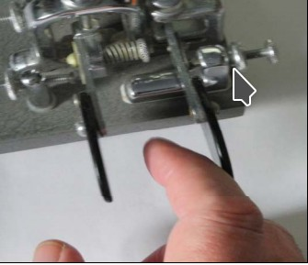

Demonstration of the described movement can be viewed and listened to by going to YouTube UA3AO

384.MOV – 386.MOV. https://www.youtube.com/watch?v=GB_l1xKj90Q

To explain the movements of the hand in the transmission of signs, we denote the thumb with the letter

"B", and the index finger - "U". Movement to the right - "P" move to the left - "L". The right handle is

only used to transmit with two or more dashes. Let's start with the transfer of figures or digits:

1 DIT-DASH-DIT-DASH-DIT

2 DIT-DASH-DIT-DASH

3 DIT-DASH-DIT

4 DIT-DASH

5 DIT

6 DASH-DIT

7 DIT-DASH-DIT

8 DASH-DIT-DASH-DIT

9 DIT-DASH-DIT-DASH-DIT

0 UL ("short zero") UL-UP-UL-UP-UL

Note: only 7 and 9 start with UE

А DIT-DASH

Б DASH-ВП

В BP-UL-UP

G UP-UL-BP

Д DASH-DIT

Е DIT

Ж DIT-DASH

З DIT-DASH-DIT

And BP-BP-UP-UL-UP

K UL-BP-UL L BP-UP-BP

М DASH-DIT

Н DASH-DIT

О DASH-DIT-DASH

П DIT-DASH-DASH-DIT

Р DIT-DASH-DIT

С DIT

Т DIT

У DIT-DASH

F DIT-DASH-DIT

Х DIT

Ц DASH-DIT-DASH-DIT

Ч DASH-DASH-DASH-DIT

Ш DIT-DASH-DIT-DASH

Щ DIT-DASH-DIT-DASH

Э DIT-DASH-DIT

Ю DIT-DASH-DIT

B UL-BP-UL

Ya BP-UP-BP-UP

? BP-UL-UL-BP

! UP-UL-BP-UL-UP

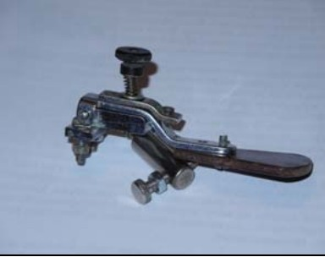Note: - the transfer of characters that have two dashes at the beginning, start with the UE.

The desire to master the work on BUG-e with two

The desire to master the work on the BUG-e with the added “cootie dasher”.

Add a second handle to the existing key.

Several variants of such revision are shown in photo 17, 18, 19.

The design can be any of these, but whatever design is used, it must ensure the closure of

the keying line by moving the paddle to the right.

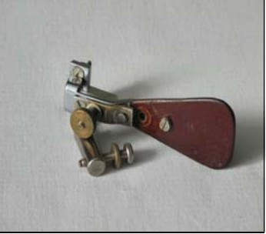

PHOTO 17

PHOTO 18

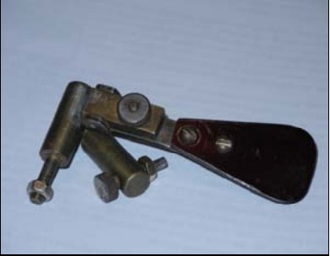

PHOTO 19

The distance between the levers is the working space of the index finger

should be 34-35 mm.

Throughout the entire period of mastering the work on BUG-e with two pen-

keep the speed of 120-130 characters per minute (24-26 wpm). Only in proportion to the pre-

error-free transmission within 2-3 minutes, you can increase the speed of signals to 150 cpm (30 wpm),

but if there is no special predilection for QRQ, then this can be done and not to do at the user’s choice.

High-quality transmission with a speed of 120-130 characters per minute will be guaranteed.

Compared with work on an electronic key, BUG is more "obedient"

and when working at the same speeds, the probability of a BUG-e error is lower,

than on an electronic key.

Here are some modified BUG models, that have been equipped with a second lever, or “cootie

dasher.”:

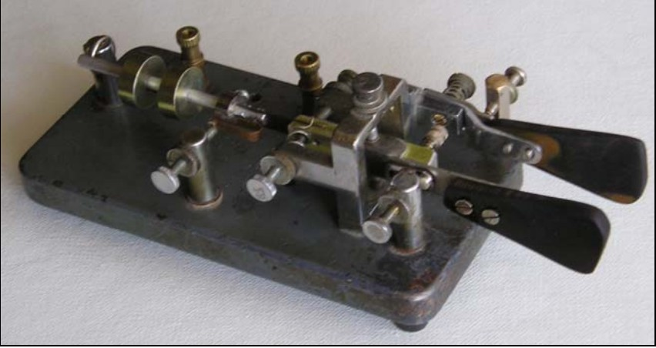

PHOTO 20

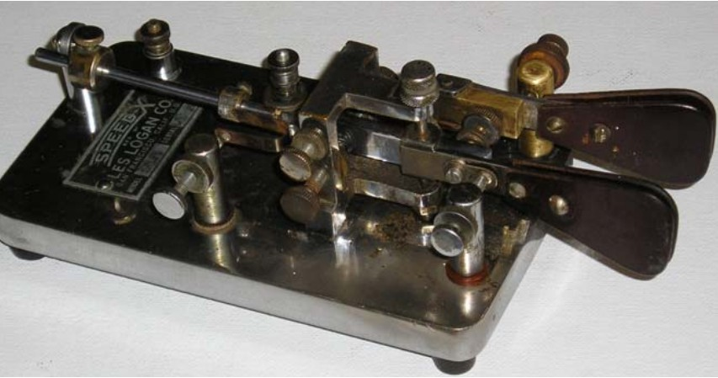PHOTO 21

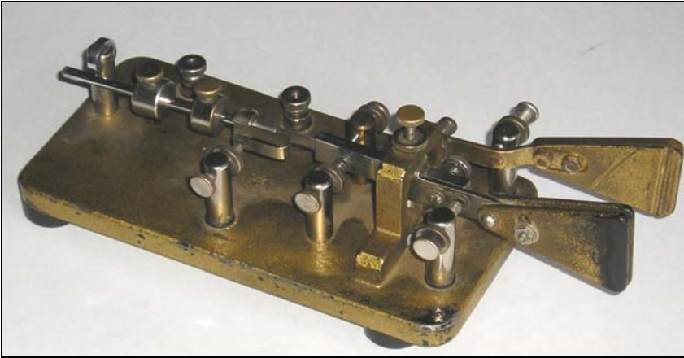

PHOTO 22

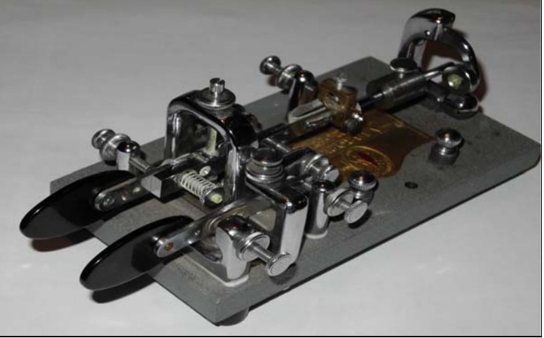

PHOTO 23

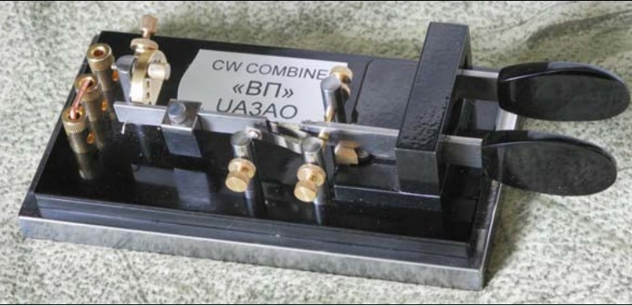

PHOTO 24

Original by

Валерий Алексеевич Пахомов

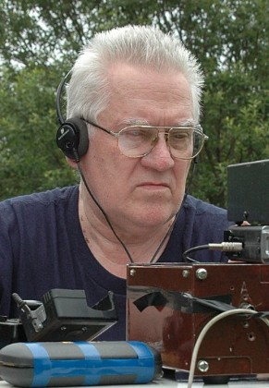Valeriy Alekseevich Pahomov, UA3AO

Translation by David J. Ring, Jr., N1EA