Calvert County
Auxiliary Communications Service
Emergency Operations Plan

Version 2023-01

RevB

Table of Contents
Chapter 1: Who We Are 3
Chapter 2: Mission 3
Chapter 3: Membership 3
AUXCOMM Member 4
Official Emergency Stations (OES) 4
Assistant Emergency Coordinators (AECs) 4
Emergency Coordinator (EC) 4
ARESMAT 5
Chapter 4: Operations Plan 5
Chain of Command 5
Alert Status 5
Notification of request for AUXCOMM 6
Intra-county Communications 6
Intrastate Communications 8
Interstate Communications 10
Operational Frequencies 11
Chapter 5: Training Plan 13
Minimum Training Requirement 13
FEMA - National Incident Management System 13
ARRL 13
Chapter 6: Leadership 14
Emergency Coordinator & RACES Officer 14
Assistant Emergency Coordinators 15
Official Emergency Stations 15
AUXCOMM Membership 16
Section Leadership 17
Chapter 7: Pre-defined Deployment Locations 17
Emergency Management 17
Chapter 8: Served Agencies 18
Calvert County RACES 18
Calvert Memorial Hospital 20
Calvert County Health Department 20
Drum Point/Rach Club Property Owners Association 20
Maryland-DC Emergency Hospital Net 21
Chapter 9: Administrative 21
Chapter 10: Incident Forms 22
NIMS ICS Forms 22
Non-ICS Forms 22

Who We Are
Calvert County Auxiliary Communication Services (AUXCOMM) consists of licensed amateurs who have voluntarily registered their qualifications and equipment for communications duty in public service. Every licensed amateur, regardless of membership in the American Radio Relay League (ARRL) or any other local or national organization, is eligible to apply for membership in the AUXCOMM. Training may be required or desired to participate fully in AUXCOMM.
Calvert County AUXCOMM is responsible for meeting the requirements of Calvert County Radio Amateur Civil Emergency Services (RACES) as administered through Calvert County Emergency Management (CCEM) as well as the Amateur Radio Emergency Services (ARES) mission.
Calvert County ARES is sponsored by Calvert Amateur Radio Association (CARA).

Mission
The mission of Calvert County AUXCOMM is to provide communications support for governmental and services organizations in routine and emergency situations utilizing amateur radio resources IAW Title 47, Volume 5, Part 97 of the Federal Communications Commission's rules and regulations.

Membership
Any person holding an amateur radio license, living or working within the political geographical limits of Calvert County, Maryland, may apply for membership to Calvert County ARES.
The membership will consist of:
- AUXCOMM Members
- Official Emergency Stations (OES)
- Assistant Emergency Coordinators (AEC)
- Emergency Coordinator (EC)

AUXCOMM Member
The AUXCOMM member is a member of the team who has submitted a request to join and such request has been approved by the AUXCOMM EC. The AUXCOMM member must possess an amateur radio license and be capable of maintaining a minimum operating capability (2 meter FM simplex and repeater communications) for a period of at least 8 hours.
AUXCOMM members should be deployable to sites of need within Calvert County and maintain a minimum operating capability.

Official Emergency Stations (OES)
Official Emergency Stations (OES) must be a full member of the ARRL, be experienced in AUXCOMM operations, participate regularly in drills, tests, and activations, and meet the minimum training requirements as set forth in the training section. An OES should be considered a good mentor and be able to provide leadership when needed.

Assistant Emergency Coordinators (AECs)
Assistant Emergency Coordinators (AECs) will be appointed by the Emergency Coordinator (EC) to function as leaders of specific tasks or be liaisons to certain served-agencies. The general duties, outside of specific duties of each AEC, is to provide leadership within the AUXCOMM organization. AECs should be trusted and trained individuals that can operate an event without direct oversight of the EC.
Specific roles that need to be filled by AECs are:
- Operations
- Planning
- Public Information Officer
- Training
And liaison positions are:
- Drum Point/Ranch Club Property Owners' Association
- RACES (Calvert County)

Emergency Coordinator (EC)
The Emergency Coordinator (EC) is in charge of the AUXCOMM program within a specified geographic area (in this case the county of Calvert in Maryland). Charged with organizing the local ARES program and meeting the needs of our served agencies, the EC is responsible to the Maryland-DC Section ARES leadership and to the amateur community within Calvert County. The EC works to create a team ready to respond to emergencies and routine requests for communications assistance. The EC application & appointment is approved by the ARRL Section Manager.

ARESMAT
The ARES Mutual Assistance Team (ARESMAT) is made up of volunteers that can deploy to neighboring counties to support emergencies.

Operations Plan
In general, it is assumed that communications support requests will come from organizations within Calvert County. It is also assumed that because our primary and secondary voice repeaters are located in a semi-hardened facilities that these resources will be available for any emergency response. In the event any of our infrastructure is not available, AUXCOMM will revert to the output frequency of the 2M repeater (146.985 MHz) as our primary operating frequency.

Chain of Command
Calvert County AUXCOMM will operate under the Incident Command Structure. A member of the AUXCOMM team will be placed in charge and will be responsible for the overall operation of an event. For a variety of reasons, the leader may not be EC so AEC(s), RACES Officer(s ) and OES(s) should be prepared to assume control when needed. Sub-teams may be created with team leads to fulfill certain missions.
The EC shall be the primary point of contact for requests for service. In the event the EC will be unavailable they shall assign the duties to another team member to serve as the primary point of contact. In the event the EC or duty-EC cannot be contacted, contact should be attempted with another AEC or OES.

Alert Status
Three categories of alert status are used to provide readiness notification to AUXCOMM members.

Non-Alert Readiness
This is the default level of readiness. No emergency is expected. Monitoring one of the main operational channels is encouraged.

Standby Alert
A call-up is possible. If a call-up is anticipated, members should make ready their stations ready for an activation and/or deployment. All AUXCOMM members should monitor the primary channel to the maximum extent.

Emergency Alert
When an activation is requested the following guide should be used:
- A net should be established on the primary channel and all AUXCOMM members should check in. Net control should maintain a log of all stations checked in and activities. The net control operator will be designated by the EC or AEC.
- Net control should designate a station to monitor the Central Region repeater (147.105 MHz PL 107.2) and/or Section Net (MEPN).
- The duty-EC should communicate with the Incident Commander (or their designated representative) to determine the services needed to support the event and start making assignments.

Notification of request for AUXCOMM

Routine Requests
If a served agency knows of an upcoming event in which they are requesting service with they should contact the EC, or in his absence, the duty-EC or an AEC. They will then relay the information to the team using the CALV-ARES email reflector and/or any other means necessary to meet the request.

Emergent Requests
Emergent requests for service will likely require a full call up of all members. The following procedure should be used for notifying all members:
- Announce on the primary repeater the request for service. If possible, establish a net with a team member already on the frequency and have them do a roll call.
- Transmit a message to the text alert group which will deliver the request to team member's phones.
- Start a call-up of the phone tree skipping stations that have already joined the net.

Intra-county Communications
As amateur radio operators, Calvert County AUXCOMM has access many frequency options. Depending on the size of the operation a VHF or UHF simplex channel may be all that is necessary to maintain communication for the objective. County-wide communications can easily be maintained using the primary and secondary repeaters. Suggested operational frequencies can be found in the ICS-205 (below) which is periodically updated, so check for the latest version.

Digital Communications

Winlink
Winlink is an Internet-connected radio email system that provides potentially long-haul communications between Winlink users or to anyone with an e-mail address, but can also be used for station-to-station communications without the Internet. Small attachments are possible with Winlink messages.
Winlink on VHF/UHF frequencies typically requires a packet terminal node controller (TNC) capable of KISS mode or a software emulation of the TNC, a VHF/UHF FM transceiver and the Winlink Express client software on a laptop computer. Winlink on HF frequencies requires a HF transceiver and cabling to interface with the sound card in a computer, or a stand-alone sound card interface like the Signal Link. The Winlink Express client software includes HF WINMOR mode to transmit Winlink messages on HF. A newer digital mode, VARA, is available separately at https://rosmodem.wordpress.com/ and run access is integrated into the Winlink client program. VARA requires a sound card for HF, VHF and UHF operations and is considerably faster than basic Winlink Packet.

Winlink Peer-to-Peer
Using similar tools, Winlink peer-to-peer (P2P) can be used for communications between stations to transmit short or long messages on VHF/UHF as well as HF. This mode is preferable to Internet-connected modes as the availability of the distant end, and all nodes in between, are immediately known and workarounds can be made. This mode is often faster than using Winlink. VARA can also be used for peer-to-peer communications.

MT63-2000L
MT63 is a multi-tone robust digital modem with strong forward error correction and is available in the popular FLDIGI set of programs at https://sourceforge.net/projects/fldigi/ MT63 requires a sound card interface between the radio and the computer. Unlike Winlink, any station receiving a reasonable signal level can copy the traffic which helps with overall situational awareness. MT63-2000L can be used on VHF and UHF frequencies, MT63-1000L on 6M and 10M, and MT63-500L on the lower HF bands. MT63 is the preferred digital mode WITHIN Calvert county.
Winlink has become the digital standard for the Mid-Atlantic ARES organizations. It is expected that all Calvert AUXCOMM members will establish Winlink capability of some level in their stations and GO-KITS, along with MT63.

APRS
Automated Packet Reporting System (APRS) is a specialized digital network that allows stations to provide their geographical location. Sending short messages also possible as well. Calvert AUXCOMM members with APRS capability should make themselves proficient with APRS messaging.
APRS can be used as to an alternate means of communicating in situations that benefit from this mode of operation.

Intrastate Communications
Communications with other parts of the state will generally be conducted using one of the Central Region ARES / RACES repeaters or one of the Maryland-DC Section HF nets. This does not preclude communicating with other counties directly if ARES or RACES isn't activated at the section level.
Important frequencies include:
3.820 MHz Maryland Emergency Phone Net
147.105 MHz (+, PL 107.2) W3VPR Central Regional Net
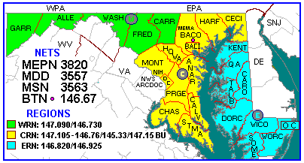
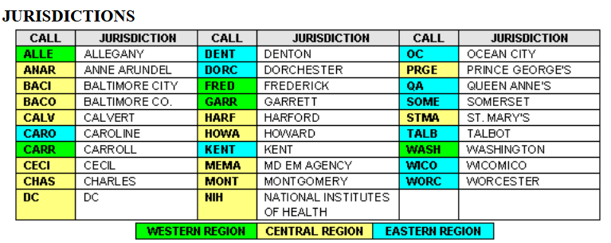

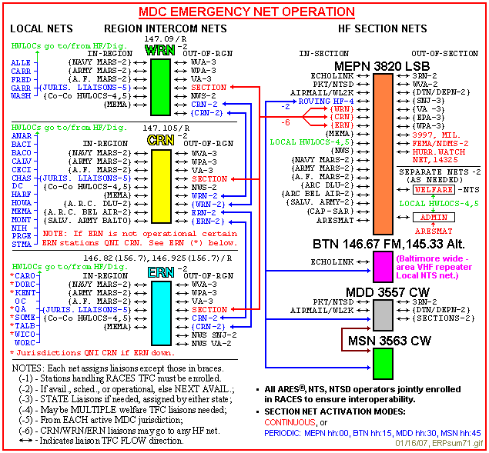
Utilizing the same digital modes as described in the intra-county section should be considered if movement of large amounts of information is required.

Interstate Communications
Interstate communications may be particularly useful after an event to shuttle health-and-welfare traffic in to and out of a disaster area. There are three main ways of moving messages out of state:
- NTSD – The NTSD is an all-radio network of BBSs servicing all fifty states, Canada, and some countries in Europe. This system will route a message to as close to the delivery point as possible (usually section level) to be delivered by an NTS station.
- NTS Section Nets – Similar to the NTSD, the NTS Section Net meets several times a day to collect traffic going out of state and bringing traffic destined for the Maryland-DC area in for delivery. While a bit slower than using the NTSD, the traffic nets are usually the easiest method of moving traffic out of the area.
check
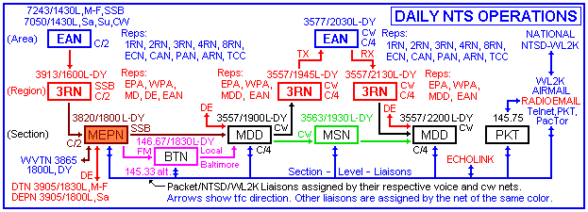

THE GOLDEN RULE – IN AN EMERGENCY, MOVE TRAFFIC BY THE BEST MEANS AVAILABLE. That may not be amateur radio if a functional phone connection, internet connection or FAX connection is available.

Operational Frequencies
The Calvert AUXCOMM ICS-205 defines the frequencies to be used. This document may be updated periodically. All the RACES radios (VHF/UHF) at the EOC are programmed as shown. It is strongly recommended that Calvert AUXCOMM members either program their radios identically or have a paper copy of the latest ICS-205 in their GO-KITS.
Table 1: Operational Frequencies

Training Plan
All ARES members should be properly trained to respond to emergencies. Training will come from both formal training classes from FEMA, ARRL, and other organizations as well as in-house training. Each AUXCOMM member should maintain a ARES® EMERGENCY COMMUNICATOR INDIVIDUAL TASK BOOK.

Minimum Training Requirement
Due to our close relationship with local and state governmental entities it is important to understand how to integrate with their existing command structure. In order to foster that relationship, the NIMS/ICS training (as described below) should be completed.
Additional in-house training will likely become part of the minimum training.

FEMA - National Incident Management System
The National Incident Management System (NIMS) is a series of federal Incident Command System (ICS) training courses that help individuals operating with federal, state, and local governments, as well as private companies, and to help understand how to operate within the ICS system. Because it is mandated that all federal incidents will be handled under the ICS, many states and local authorities have also adopted this structure to be continuously ready to respond to any incident.
Within the ARES structure, members should, and RACES members, OES(s), AEC(s), and the EC must, complete the following NIMS courses:
- IS-100.b – Introduction to Incident Command System
- IS-200.b – ICS for Single Resources and Initial Action Incidents
- IS-700.a – National Incident Management System (NIMS), An Introduction
- IS-800.b – National Response Framework, An Introduction
NIMS courses are available on the FEMA Training website (http://training.fema.gov/IS/NIMS.aspx).

ARRL
The American Radio Relay League makes available training courses that help prepare the ARES member to responding to emergencies.

Intro to EmComm (EC-001)
This course is designed to provide basic knowledge and tools for any emergency communications volunteer.

Public Service and Emergency Communications Management for Radio Amateurs (EC-016)
This course is designed to train licensed Amateur Radio operators who will be in leadership and managerial roles organizing other volunteers to support public service activities and communications emergencies.

ARRL Public Relations (EC-015)
This course is designed to give hams a quick overview in public relations activities. It uses the skills of experts in various aspects of public relations to provide volunteer Public Information Officers with the basic skills and expectations that a PIO needs to know to be effective in their home region.

Leadership

Emergency Coordinator & RACES Officer
Table 4: Emergency Coordinator contact information
Name | Function | Callsign | Primary Telephone | Secondary Telephone | E-Mail
Shawn Donley | EC | N3AE | 410-535-5236 | 240-298-3115* | n3ae@arrl.net
Bill Hackett | RACES | N3XMZ | 443-404-1047* |  | n3xmz.md@gmail.com
* SMS capable

Assistant Emergency Coordinators
Table 5: Assistant Emergency Coordinator contact information
Name | Callsign | Primary Telephone | Secondary Telephone | E-Mail
Operations -  Andy Charland | KC3WRX |  |  | acharland182@gmail.com
Planning - | Vacant
Logistics | Vacant
Finance/Admin | Vacant
Public Information Officer - | Vacant
Training - | Vacant
Public Service - | Vacant
Drum Point POA - | Vacant

Official Emergency Stations
Table 6: Official Emergency Station (OES) contact information
Name | Callsign | Primary Telephone | Secondary Telephone | E-Mail

AUXCOMM Membership
Table 7: AUXCOMM Membership contact information
(Subject to changes)
Name | Callsign | Primary Telephone | Secondary Telephone | E-Mail
Wade F. Mahaffey III | KB3VLE | 301-904-2940 |  | kb3vle@gmail.com
Brian Kress | KB3WFV | 301-641-1674 |  | kb3wfv@yahoo.com
Erik Johnson | KC3QQD | 410-535-9011 | 443-532-8691 | kc3qqd@comcast.net
Dale Sollars | KC3RKP | 603-991-6613 |  | dsollars21@gmail.com
Andrew T. Charland | KC3WRX | 301-509-5940 |  | acharland182@gmail.com
Les Silva | KH6CUJ | 410-257-5438 | 301-704-1274 | kh6cuj@aol.com
Shawn Donley | N3AE | 410-535-5236 | 240-298-3115 | n3ae@comcast.net
Peter Hughes | N3PH | 443-975-1215 |  | info@dahughes.com
Bob Sheskin | N3PPH | 410-487-2503 |  | n3pph@comcast.net
Bill Hackett | N3XMZ | 443-404-1047 |  | n3xmz.md@gmail.com
Dave Weaver | W3PQS | 443-964-4344 | 240-882-0484 | w3pqs@comcast.net
Richard Ratcliff | W3RBR | 410-414-7315 | 301-848-8999 | rratcliffe@comcast.net
Steve Minerd | W3SMM | 412-583-1460 | 412-583-1460 | w3smmradio@gmail.com
Edward H. Zumstein | WB6NCO | 301 938 4999 | 301 855-0819 | ezumstein@comcast.net

Section Leadership
Table 8: ARES Membership contact information
Name | Position | E-Mail
Christopher Van Winkle, AB3WG | Section Manager | ab3wg@arrl.org
Al Nollmeyer, W3YVQ | Section Traffic Manager | w3yvq@arrl.net  w3yvq@winlink.org
Jim Montgomery, WB3KAS | Section Emergency Coordinator | wb3kas@aol.com  wb3kas@winlink.org
Jay Nardone, W3SCA | Central District Emergency Coordinator | w3sca@arrl.net

Pre-defined Deployment Locations

Emergency Management

Emergency Operations Center
Use: County emergency operations center and control point.
Location: 175 Main Street, Prince Frederick, Maryland 20678
Cross-streets of Duke Street and King George Way. Park in the lower lot off of Duke Street and enter from southwest corner door at the rear of the building.
Coordinates: N 38.53819 W 076.58286
Phone: +1 410 535 1600
Fax: +1 410 535 3997
Pre-Deployed Equipment: Two-meter radio and antenna.
Coverage: Using antennas on the tower at Barstow:
2M 20 watts 70cm 20 watts
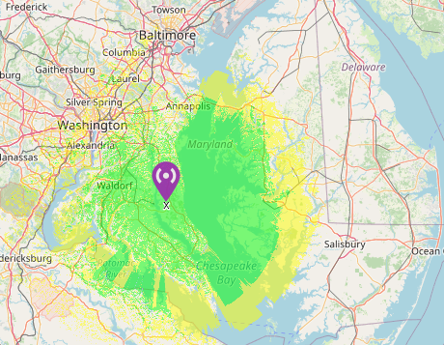
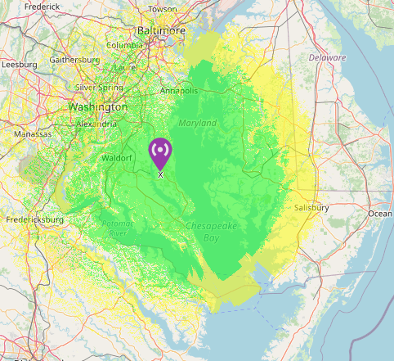

Huntingtown High School
Use: Public shelter
Location: 4125 North Solomons Island Road, Huntingtown, Maryland 20639
Cross-streets of Scarlett Drive and Cox Road. Park in northern lot and enter school using northern entrance.
Coordinates: N 38.6197 W 076.6089
Phone: +1 410 414 7036
Fax: +1 410 535 2865
Pre-Deployed Equipment: None
Coverage: Dependent on antennas erected for callout

Patuxent High School
Use: Public shelter
Location: 12485 Southern Connector Boulevard, Lusby, Maryland 20657
Cross-streets of HG Trueman Road and Sousby Hall Road.
Coordinates: N 38.3558 W 076.4383
Phone: +1 410 535 7865
Fax: +1 410 535 7875
Pre-Deployed Equipment: None
Coverage: Dependent on antennas erected for callout Fire and EMS Stations

Served Agencies

Calvert County RACES
Calvert County ARES is responsible for meeting the requirements of Calvert County Radio Amateur Civil Emergency Services (RACES) as administered through Calvert County Emergency Management (CCEM). The RACES Officer (RO) provides the interface between CCEM and Calvert AUXCOMM and is responsible for the RACES operation.
97.407 of the FCC rules provides for RACES. RACES is a special phase of amateur operation sponsored by FEMA, that provides radio communications for civil preparedness purposes only, during periods of local, regional or national civil emergencies.
Calvert County RACES is responsible to the Logistics Section Chief within the unified command structure of the CCEM team. CCEM has expectations of support from RACES in the areas of preparedness, response, recovery, and mitigation. Overall, CCEM expect RACES to:

- Provide support for emergency support function (ESFs) 2- Communications, 5- Emergency Management, 6- Mass care, Emergency Assistance, Housing and Human Services.
- Coordinate and provide emergency communications for outlying areas, local shelters, Maryland Emergency Management Agency in the emergency operations center (EOC).
- Provide backup communications between adjacent county EOCs.
- Provide other communications services requested if within the scope or capability of RACES personnel to do so.
- Participate in training and exercises as determined by the Director of Emergency Management.

Preparedness
- Participate in planning, training and exercises
- Maintain member notification roster
- Maintain group resources.
- Assist in resolving ESF 2 after-action issues.
- In conjunction with EMD develop supporting plans and procedures.
- Provide assistance in resolving ESF 5 related after-action issues.
- Maintain inter-agency notification roster.
- Maintain inventory of agency resources.
- Assist in resolving ESF 6 after-action issues.
- Train agency staff for emergency operations.
- Develop supporting plans and procesures.

Response
- Provide communications support using the RACES/ARES network.
- Provide technical assistance.
- Provide representation to EOC when activated.
- Provide support in maintaining communications with shelters, other emergency facilities, and neighboring county EOCs.
- Provide assistance in conducting emergency notifications.
- Provide supplemental weather information by monitoring Skywarn activities when active.

Recovery
- Provide communications support.
- Participate in after-action review.

Mitigation
- As appropriate, identify opportunities to mitigate the impact of future incidents.

Calvert Memorial Hospital
TBD

Calvert County Health Department
Calvert AUXCOMM maintains a VHF/UHF radio system, including a permanent roof-mounted antenna at the Calvert Health Department. The Kenwood TM-D710 radio, Kantronics KPC-3+ and power supply/battery backup are on a cart normally stored in the IT technician’s room. The SO-239 connector to the roof antenna is on the wall in the first floor conference room.

Drum Point/Rach Club Property Owners Association
A standing request for service is established. A request by best means available to the Calvert County ARES Emergency Coordinator from the Drum Point CESC shall result in the establishment of communication channels between the Drum Point CESC, Calvert ARES and Calvert County government, dependent on the extent that Calvert County Government mobilizes, and further agreements that Calvert County ARES has with Calvert County Government.
- Communications channels between other locations or served agencies shall be on an as requested basis (e.g. between Drum Point CSEC and the Calvert County Government Southern Evacuation District Primary and/or Secondary Shelters. Each organization will encourage ongoing liaison with the other, urging both staff and volunteers to create and maintain adequate communication and effective relationships at all levels.
- Each organization will participate in cooperative pre-disaster planning and training programs at local, regional and national levels.
- Shared members: Each organization will encourage interested volunteers to become members and participate in the activities of the other organization. Such volunteers shall meet the standards of each organization.

Maryland-DC Emergency Hospital Net
The Maryland-DC Emergency Hospital Net (HFHN) is a HF voice net that links hospitals around Washington, D.C. together. CalvertHealth Hospital and Calvert County Health Department are targets of this network. Although no formal cooperative agreement between CalvertHealth and Calvert AUXCOMM exists at this time, the proximity of the hospital and health department makes it possible to establish a communications link from the hospital to the health department with minimal equipment.
------------ STOPPED HERE ------

Administrative
Monthly EC Report
Each month the EC, or their designated alternate, should file a report to the Section Emergency Coordinator (SEC). The SEC uses this report to produce a report that goes to the ARRL as well as shares some of the interesting information with the rest of the section. The report should be emailed to the SEC by the 10th of each month, with the title of the email being the county four letter code and numerical month of the year. For example, the report for May 2023 would use the email title 2023-05 CALV EC Report. The report uses a fillable pdf form shown below.
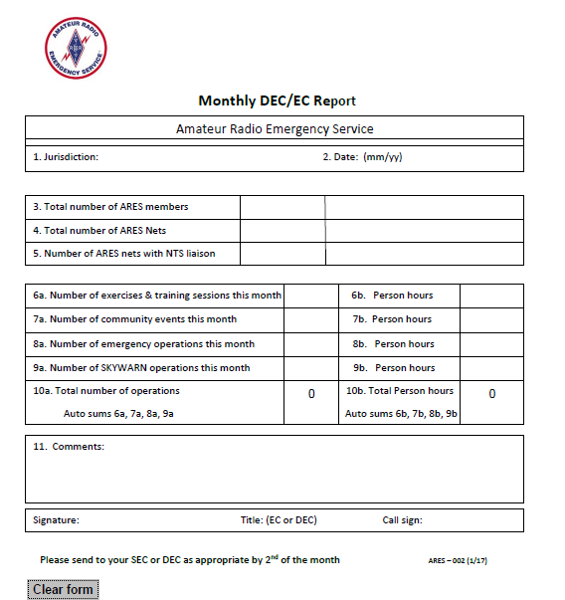

Incident Forms

NIMS ICS Forms
NIMS ICS forms are standardized to allow information to be passed between agencies without confusion. The most used forms are contained within this chapter:
- ICS-205 – Incident Radio Communications Plan
- ICS-213 – General message form
- ICS-214 – Activity Log
- ICS-309 – Communications Log

Non-ICS Forms
- EOC SITREP – Incident Status Report in General Forms Template
- ARRL RADIOGRAM Template

The copies below are taken from the Winlink 2000 forms template library. There are many templates available but use the template which best matches the needs of the supported organization. Normally these will be ICS forms.
A software package called flmsg can be downloaded at https://sourceforge.net/projects/fldigi/files/ and provides various message templates compatible with FLDIGI and the MT63 digital mode. Note: These templates may not exactly duplicate the Winlink 2000 templates in format and layout but should contain the same information cells.
