Calvert AUXCOMM
Simulated Emergency Test 2022 After-Action Report

Introduction:
This report summarizes the activities during the Calvert AUXCOMM Simulated Emergency Test (SET) conducted on Oct 15, 2022. The SET plan appears in the Appendix and should be consulted first to understand the task objectives chronology described below.
The main objective of the exercise was to map out the 2M and 70cm simplex coverage from the Diamond X300 antenna on the Barstow tower (at 350 ft on the NNE face). The secondary objective was to see if the MT63-2000L mode would work with a radio using RemoteRig to connect the radio panel to a remote RF deck.

Participants included:
N3AE
KC3WRZ
WB6NCO
N3PPH
W3PQS
N3IVK
N3XMZ
N3PH
KC3QQD
KC3RKP
General Observations/Lessons Learned:
- MT-63-2000L via RemoteRig - The MT63-2000L test on either 146.580 simplex or via the 146.985 MHz repeater between the EOC and N3PPH was unsuccessful. At the EOC end, we simply held the radio microphone close to a laptop computer running FLDIGI and conversely held the computer microphone close to the speaker connected to the RemoteRig terminal. RemoteRig digitizes the microphone audio and ships it in Ethernet packets to the terminal at the RF deck where it is converted back into analog audio. The RemoteRig terminal configuration was for audio quality 2, which is linear 16 bits 8 kHz sample rate (default). Perhaps this sample rate is fine for voice but inadequate for passing MT63-2000L tones. Additional testing is planned.

- Simplex Frequency – Picking 146.580 MHz for our exercise frequency was probably a mistake. With the EOC antenna at 350 ft up the tower, that frequency was fairly crowded. At the EOC we could hear other simplex communications including some communications associated with a bicycle event of some sort. In the future, we should pick a different simplex frequency that is unlikely to have so much traffic. Simplex on 444.950 MHz did not suffer similar problems.

- Simplex coverage of the county on both 2M and 70cm was surprisingly good using the Diamond X300A mounted at 350 ft on the north-northeast face of the Barstow tower. The table and map below summarizes the tests from various locations within or just outside Calvert County. The map shows where mobile stations were located when they called in using a simplex frequency. No mobile stations crossed over to Charles County but our coverage there (and likely the eastern shore) is also suspected to be good. The table delineates copy as either Good or Marginal, with the left column being copy of the mobile station AT the EOC and the right column being the copy of the EOC AT the mobile station’s location.

- N3PH was using a 70cm hand held operating at 5 watts and in most cases copy was good.

- Perhaps another exercise using HT’s from various locations might be worth doing.

- Having a second operator at the EOC to handle coordination using the 146.985 MHz and 444.950 MHz repeaters proved to be essential. I doubt one operator could have handled both the simplex communications and calls over the repeaters. Many thanks to KC3WRX for being at the EOC to handling the repeater communications. We used the separate Kenwood TM-V71A radio that’s connected to an antenna on the EOC roof for the repeater work.

- Our thanks also to Calvert emergency management, Mike Grierson, for providing access to the EOC. Normally, we could be “buzzed in” from the 911 dispatch room but they were operating at their alternate site on October 15th.

- Our longest range contact was with KB2TSE near the Mt Weather complex in Virginia, about 80 miles northwest of Barstow. He reported us as a strong and clear signal, as was his. This contact not shown on the map.

Note: The power used at the Barstow tower was typically 10 watts (medium power for the TM-V71A) on both 2M and 70cm. Occasionally we changed power to high (50w) or low (5w) to check the effect.
Note: The above table is available in this Excel file.

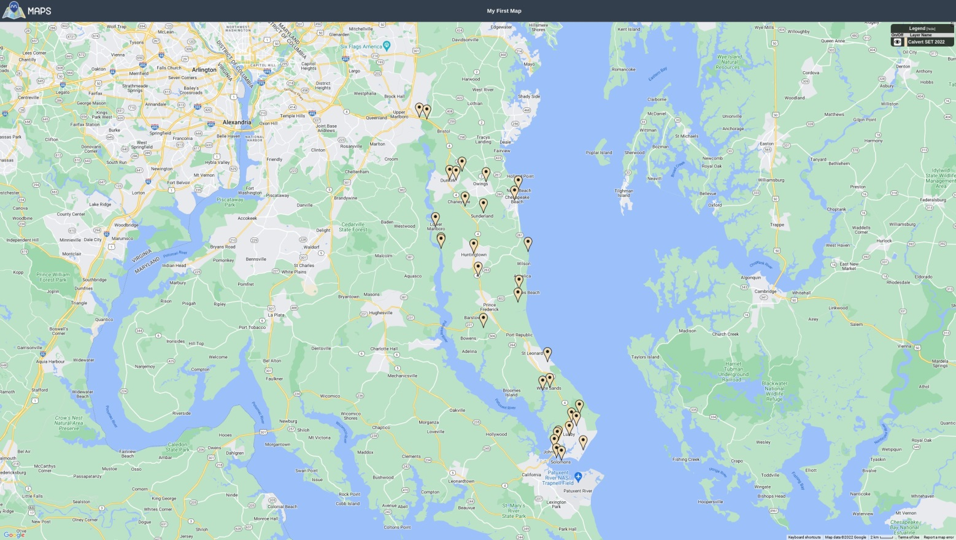

Map indicates locations of mobile stations checking in with the EOC
Using Simplex Frequencies

All,
This year we will not be having a Section Level Simulated Emergency Test but rather a local SET here in Calvert.
.
PLEASE LET ME KNOW IF YOU CAN PARTICIPATE (and in what capacity after reading the draft plan below).

PRINT OUT THIS PLAN !
OBJECTIVE: The primary objective of our SET is to map out the 2M and 70cm mobile simplex coverage from our antennas on the Barstow tower. The secondary objective is to test MT63-2000L via the 146.985 repeater using the EOC’s RemoteRigs which connect the radio panels to remote RF decks. The objective of this test is to determine if the RemoteRigs introduce any artifacts that prevent successful communications using the MT63-2000L mode.

WHEN: The morning of Saturday, Oct 15th from 09:00 to 12:00. At the conclusion of the SET, we will meet for lunch at Three Brothers in Prince Frederick or, if weather permits, meet at a TBD local park for a picnic.
WHERE: Net control will be at the Courthouse EOC
Participating stations will go mobile and try to check in with the EOC on simplex while still at their home QTH and then from a number of locations within some radius (5 miles or so) from their home QTH. Predicted coverage maps for both 2M and 70cm are included at the bottom of this plan. Green is good coverage. Yellow is marginal. White is no signal. The predicted coverage is for the antenna at 350 ft at Barstow working a mobile with 20 watts at both ends. I’ve found this particular coverage software to be optimistic, particularly on 70cm, so use as rough guidance only. It doesn’t account for tower shading effects (the main antenna for this exercise is at 350 ft is on the NNE face of the tower). At the EOC, we will also monitor using the SSE facing antenna which is at 250 ft up on the Barstow tower.
MODES: The primary mode will be FM voice on 146.580 MHz simplex and 445.500 MHz simplex. The CARA 146.985 repeater will be used for testing MT63-2000L with 146.580 simplex as a backup. NCS will use both the CARA 146.985 and 444.950 repeaters for coordination and control during the exercise.

EXECUTION:

- NCS will call the SET to order at 09:00L using the 146.985 repeater followed by the 444.950 repeater. Stations need only check in on one of the two repeaters. Participants will check-in using either their home stations or mobile rigs at the home QTH. NCS will create a list of SET participants based on these check-ins.

- NCS will conduct a short MT63-2000L transmission and reception test using the 146.985 repeater with a TBD home station equipped for, and experienced with, using this digital mode. As a backup, 146.580 simplex might be used for this test. All participating stations are welcome to copy the digital traffic if so equipped.

- After the MT63-2000L test, but hopefully no later than 09:30, NCS will request stations to check in on 146.580 simplex using their mobile rigs at their home QTH, in order, using the check-in lists created in Step #1. NCS will make this request first on the 146.985 repeater using the check-in list from that repeater and again on 444.950 using the list of stations heard on that repeater. After a successful or unsuccessful mobile check-in, all participating stations will QSY back to the146.985 repeater or the 444.950 repeater and wait for instructions. Following completion of all 2M check-ins, and as instructed by NCS, all stations will switch to 445.500 mobile simplex (if so equipped) and repeat the check-in process. Again, after a successful or unsuccessful check-in, all participating stations will QSY back to the146.985 repeater or 444.950 repeater and wait for instructions. NCS will monitor the both repeaters during Step 3 for coordination as necessary.

- At the completion of Step 3, all participants will deploy to a location of their choice within a 5 mile or so radius of their home QTH (5 miles is not a hard limit, just a suggestion). Coverage in the mid-county area near the Barstow tower is expected to be good so avoid heading that way. Locations which are suspected to have good propagation and others suspected to be bad (low spots) are desired. Public facilities like schools and parks could be a good choice. If at all possible, try to find a spot where you can park your vehicle rather than calling while driving. Once positioned, stations will call NCS on 146.580 simplex. If successful communications are achieved, NCS will ask the station to call again on 445.500 simplex. Since calls to NCS will be asynchronous, try a few times as you may be doubling with another mobile you can’t copy. NCS will continue to monitor both CARA repeaters during this step.

At each location, stations will tell NCS their call and a sequential letter to identify their location. For example, “Net Control, this is N3AE at position Alpha, how copy?.” At the station’s next location, the call would be “Net Control, this is N3AE at position Bravo, how copy?.” Since we will test simplex on both 2M and 70cm for each location, each sequential letter will appear twice in your report.

Each station is responsible for recording their location, location letter identifier, band used, power level and a signal report. A suggested template is provided below in this plan. If possible, please identify positions in your post-exercise report in latitude & longitude. You can use Google Maps after the exercise to mark your location and Google will display that lat/long. Send these records to n3ae (at) comcast.net after the exercise. N3AE will process this data and post the results on our AUXCOMM website. The number of different locations for each station is up to them.

- Once all stations have finished cycling through their selected locations, they will notify NCS using either of the CARA repeaters.

- At the conclusion of the exercise, we will meet at Three Brothers in Prince Frederick for lunch if the weather is uncooperative or at a TBD county park with bring-your-own food if weather permits. We’ll decide the day of the exercise.

- Note: The EOC has two dual band radios using antennas on the Barstow tower and two additional dual band radios with antennas on the EOC roof. One of the latter will be used for monitoring the repeaters. Since NCS will be busy, two NCS operators will be used, one to conduct the simplex tests and another to monitor the two repeaters and help with record keeping.

Post-Exercise Report to be filed by Each Participant

Location (lat/long) | Location Letter ID | Band, 2m or 70cm | Power, watts | Signal Report (Good, Marginal, No Copy)

2M Predicted Coverage, Whole County, from Barstow Tower
10 watts (medium power) on Diamond X300 at 350 ft NNE face

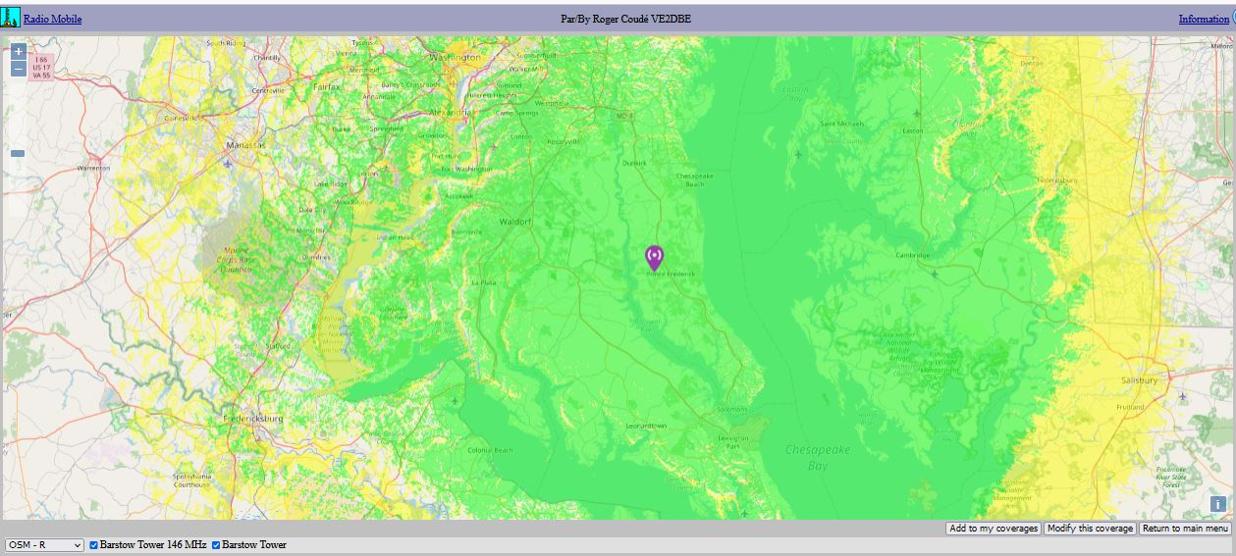

2M Predicted Coverage, South County
10 watts (medium power) on Diamond X300 at 350 ft NNE face
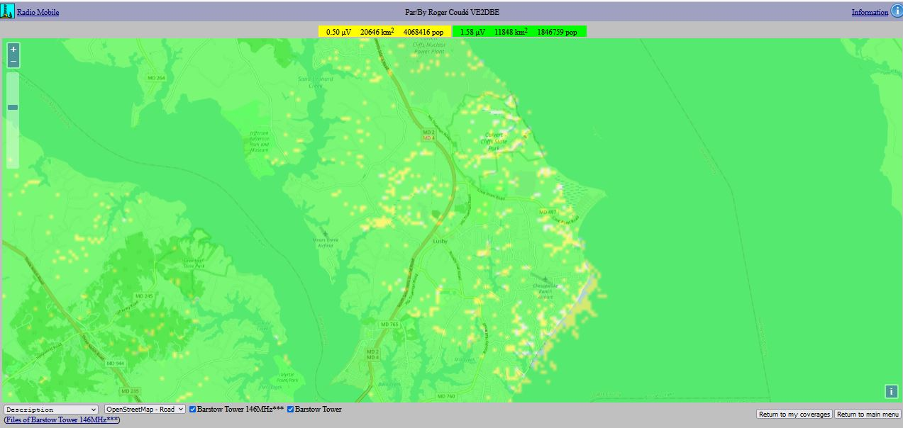

2M Predicted Coverage, North County
10 watts (medium power) on Diamond X300 at 350 ft NNE face
