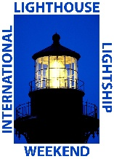
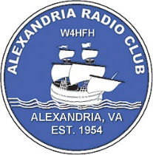
ALEXANDRIA RADIO CLUB
International Lighthouse Lightship Weekend
WHAT The International Lighthouse and Lightship Weekend (ILLW) is a highly popular annual event among amateur radio operators. It's not a contest in the traditional sense, but rather a fun and relaxed event focused on connecting amateur radio with maritime heritage.
The event is eligible for the Amateur Radio Lighthouse Program.
WHY The main objective of the ILLW is to encourage amateur radio operators to set up temporary stations at or near lighthouses and lightships around the world. Participants aim to make contact with as many other amateur radio stations as possible, particularly other lighthouse-based stations. It also serves to raise awareness about the importance and preservation of lighthouses and lightships.
WHEN For Jones Point Lighthouse, the event will run from: 0600L on Saturday, August 16th to 2200L on Saturday and 0600L to 2000L on Sunday August 17th
WHERE JONES POINT LIGHTOUSE at Jones Point Park, Alexandria, VA
From I-95/495 in Alexandria, take Exit 1 for Route 1 North. Turn right on Franklin Street. Then turn right on S. Royal Street. Turn left on Jones Point Road. Partway down this road, turn right under the Woodrow Wilson Bridge. The road ends at the parking lot.

WHO Any licensed member. Special Call Sign is: W4B
HOW US Park Service Property so park is only open 0600 – 2200 daily. Stay clear of the building and setup out in the grassy areas
No Restrictions on Equipment: There are no restrictions on antennas or power levels; operators simply comply with their national amateur radio license conditions.
No Registration Required (but Recommended): Only the first party needs to register showing Jones Point Light is participating.
https://www.lighthouse-weekend.international/index.php/entry-form

