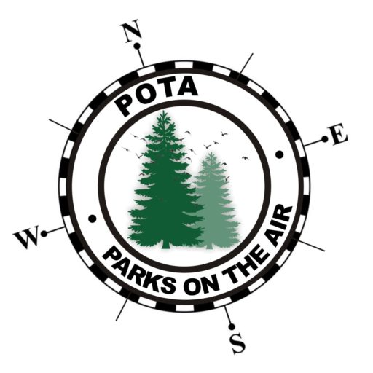
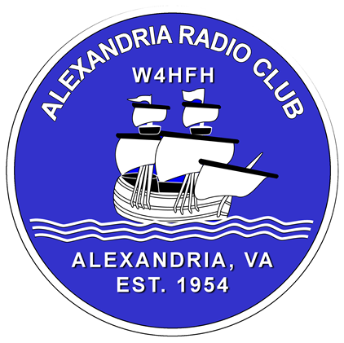
W4HFH
Alexandria Radio Club
Parks On The Air

SSB
CQ POTA CQ POTA This is Whiskey Four Hotel Foxtrot Hotel (W4HFH) at park Uniform Sierra Zero Six Seven Zero. For Parks On the Air.

Good afternoon (CALLSIGN) You are Five Nine into park Uniform Sierra Zero Six Seven Zero QSL?

Thank you for hunting and 73, this is Whiskey Four Hotel Foxtrot Hotel (W4HFH), Q-R-Zed

CW
CQ POTA CQ POTA DE W4HFH
GM (Callsign) UR 5NN 5NN VA VA BK
TU ES 73 DE W4HFH

W4HFH
Alexandria Radio Club
Parks On The Air
W4HFH
Whiskey Four Hotel Foxtrot Hotel
Parks
US – 0670 George Washington Memorial Parkway
US – 4564 Potomac Heritage Trail National Scenic Trail
US – 4567 Captain John Smith Chesapeake National Historic Trail
US – 4581 Star-Spangled Banner National Historic Trail
US – 9898 Mount Vernon National Historic Trail
US – 9935 Virginia Bird & Wildlife State Trail
US – 9961 Dyke Marsh Wildlife Reserve

